A PROJECT REPORT
SWIFT SHIP TRACKER
SALESFORCE PROJECT
Book. Track. Deliver. Smarter.

PROJECT SUBMITTED BY

TEAM MEMBERS | EMAIL ID | NM ID
RANJITH D (Team Leader) | d.ranjith042005@gmail.com | 6ECFED9E0BCA782AA1F422476E521F67
MURALIDHARAN S | muralidharan27846@gmail.com | 99B1D1F23D339ACA5D34B44CB182445B
KARTHIK RAJA J | Jayankjayank78@gmail.com | 3CC1284271600DE8FD1493860895D476
VISHWA M | vishwa200566@gmail.com | 14A832934139F799CD748D9926A6637F
GURUMUGESH S | gurumugesh06@gmail.com | 70E50A619E8DA839F814864420642079

ABSTRACT
Swift Ship Tracker is a Salesforce-based parcel management and tracking prototype designed to bring shipment information into one controlled cloud environment. The system models parcels, deliveries, senders and receivers as related custom objects and uses Salesforce configuration and automation features to support the parcel lifecycle from booking through delivery confirmation. The central design goal is to reduce dependence on registers, spreadsheets and repeated support calls by providing a consistent record of shipment information.
A notable part of the implementation is the conversational tracking path. A Prompt Builder record-summary template named “Retrieve Parcel Details” defines the information that should be presented from a Parcel record. An auto-launched Flow named “Parcel Details” receives a parcel identifier, locates the matching record and passes it to the prompt. The AgentForce agent, renamed “SwiftShip Tracker”, exposes that Flow through the “Parcel Details Inquiry” subagent. During testing, the agent was able to accept a parcel ID and return the parcel name, identifier, status, weight and estimated delivery date in a structured response.
The documentation also covers the project’s requirement study, ideation, architecture, Agile planning, Salesforce object configuration, fields and relationships, security model, permission set, agent setup, testing, results and future enhancements. The practical implementation is deliberately distinguished from planned capabilities such as broader Experience Cloud deployment, dashboards, external logistics integrations and enterprise deployment pipelines.
Keywords: Salesforce, parcel tracking, CRM, custom objects, Flow, Prompt Builder, AgentForce, Experience Cloud, automation, cloud application.

TABLE OF CONTENTS
Chapter | Section | Page
1 | Introduction | 10
1.1 | Project Overview | 10
1.2 | Background of the Project | 10
1.3 | Purpose and Motivation | 11
1.4 | Problem Statement | 11
1.5 | Report Organisation | 12
2 | System Study | 13
2.1 | Existing System | 13
2.2 | Limitations | 14
2.3 | Proposed System | 15
2.4 | Objectives and Scope | 16
2.5 | Feasibility Study | 17
3 | Ideation Phase | 18
3.1 | Customer Problems | 18
3.2 | Empathy Map | 19
3.3 | Brainstorming | 20
3.4 | Solution Selection | 21
4 | Requirement Analysis | 22
4.1 | Customer Journey | 22
4.2 | Functional Requirements | 23
4.3 | Non-functional Requirements | 24
4.4 | Resources and Technology | 25
4.5 | Roles and User Needs | 27

TABLE OF CONTENTS – CONTINUED
Chapter | Section | Page
5 | Salesforce Overview | 28
5.1 | Salesforce Platform | 28
5.2 | Platform Suitability | 29
5.3 | Developer Edition | 29
5.4 | Features Used | 30
5.5 | Prompt Builder | 31
5.6 | Salesforce Flow | 32
6 | System Design | 33
6.1 | Problem–Solution Fit | 33
6.2 | Architecture | 34
6.3 | Workflow | 35
6.4 | Data Flow | 36
6.5 | Data Model | 37–38
7 | Project Planning | 39
7.1 | Agile Approach | 39
7.2 | Backlog | 40
7.3 | Sprint Tracker | 41
7.4 | Burndown | 42
8 | Implementation | 43–53
9 | Security, Agent Setup and UI | 54–59
10 | Testing | 60–63
11 | Results and Discussion | 64–65
12 | Conclusion and Future Scope | 66
References | 67
Appendix | 68

LIST OF FIGURES
Figure | Description | Chapter
3.1 | Customer problem statements | 3–10
3.2 | Empathy map for the sender persona | 3–10
3.3 | Brainstorming and prioritisation | 3–10
4.1 | Customer journey from booking to delivery | 3–10
6.1 | Problem–solution fit | 3–10
6.2 | Solution architecture | 3–10
6.3 | End-to-end data flow | 3–10
8.1 | Salesforce Developer Edition sign-up | 3–10
8.2 | Salesforce Setup home | 3–10
8.3 | Custom object configuration | 3–10
8.4 | Prompt Builder template | 3–10
8.5 | Prompt preview | 3–10
8.6 | Flow Builder | 3–10
8.7 | Flow retrieval and assignment | 3–10
9.1 | Permission set configuration | 3–10
9.2 | Agent user assignment | 3–10
9.3 | AgentForce setup | 3–10
9.4 | Agent Builder subagent | 3–10
9.5 | Agent action configuration | 3–10
9.6 | SwiftShip Tracker activation | 3–10
9.7 | Lightning record interface | 3–10
10.1 | Testing and active agent | 3–10
10.2 | Conversation verification | 3–10

LIST OF TABLES
Table | Title | Page/Chapter
1.1 | Organisation of chapters | Relevant chapter
2.1 | Comparison of existing approaches | Relevant chapter
2.2 | Characteristics of proposed system | Relevant chapter
3.1 | Customer problem statements | Relevant chapter
3.2 | Empathy map | Relevant chapter
3.3 | Ideas considered | Relevant chapter
4.1 | Customer journey stages | Relevant chapter
4.2 | Functional requirements | Relevant chapter
4.3 | Non-functional requirements | Relevant chapter
4.4 | Hardware requirements | Relevant chapter
4.5 | Software requirements | Relevant chapter
4.6 | Technology stack | Relevant chapter
4.7 | User roles | Relevant chapter
6.1 | Problem–solution fit | Relevant chapter
6.2 | Architecture layers | Relevant chapter
6.3 | Object relationships | Relevant chapter
7.1 | Product backlog | Relevant chapter
7.2 | Sprint tracker | Relevant chapter
8.1 | Development phases | Relevant chapter
8.2 | Custom objects | Relevant chapter
8.3 | Parcel fields | Relevant chapter
8.4 | Delivery fields | Relevant chapter
8.5 | Sender fields | Relevant chapter
8.6 | Receiver fields | Relevant chapter
8.7 | Prompt template | Relevant chapter
8.8 | Flow elements | Relevant chapter
9.1 | Security profiles | Relevant chapter
9.2 | Security controls | Relevant chapter
9.3 | Permission set access | Relevant chapter
9.4 | AgentForce settings | Relevant chapter
9.5 | Interfaces | Relevant chapter
10.1 | Testing levels | Relevant chapter
10.2 | Executed test cases | Relevant chapter
10.3 | Further test scenarios | Relevant chapter
10.4 | Maintenance activities | Relevant chapter
11.1 | Results against objectives | Relevant chapter
11.2 | Challenges and solutions | Relevant chapter
12.1 | Future enhancements | Relevant chapter
A.1 | Solution components | Relevant chapter
A.2 | Custom fields | Relevant chapter
A.3 | Glossary | Relevant chapter

CHAPTER 1 – INTRODUCTION

1.1 Project Overview and Background
Swift Ship Tracker is conceived as a parcel-management application built on the Salesforce CRM platform. The project treats a shipment as a business record that passes through a sequence of operational states rather than as a single entry in a register. Booking information, sender and receiver details, delivery information and status changes are therefore organised around related Salesforce records.
The prototype uses four custom objects: Parcel, Delivery, Sender and Receiver. Parcel is the central business record. Delivery stores movement-related information, including current location and expected delivery date, while Sender and Receiver retain contact and address information. Lookup relationships connect these records so that staff can move from one part of the shipment history to another without maintaining duplicated information.
The background problem is familiar in small and medium parcel operations. A shipment may be booked through one channel, its status maintained in another, and customer questions answered by a support employee who has to search through several sources. As shipment volume grows, this approach increases the chance of missing updates and makes it difficult to obtain a consistent operational view.
Salesforce was selected because the platform combines configurable data structures, automation, security and reporting in one cloud environment. The project extends this foundation with Prompt Builder and AgentForce so that parcel information can also be retrieved through a conversational interface. The result is not merely a tracking page; it is a structured demonstration of how CRM data can support logistics operations.
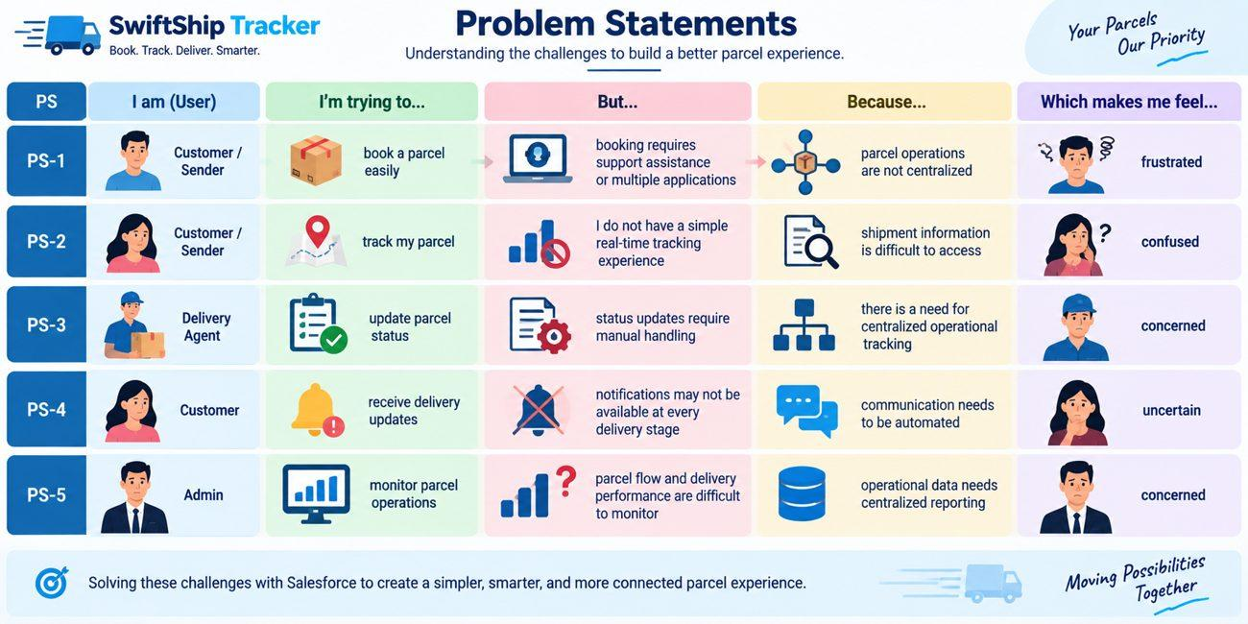
Figure 1.1: User problems represented across the parcel service context

CHAPTER 1 – INTRODUCTION

1.2 Purpose, Motivation and Problem Statement
The purpose of the system is to reduce friction in the parcel journey. A customer should be able to obtain shipment information without repeatedly contacting support, while staff should be able to maintain one reliable set of parcel records. The project therefore focuses on centralised data, status visibility, automation and controlled access.
The motivation for the work came from the repeated nature of parcel-status questions. When customers cannot see a current status, they generally ask a support team to check it. For a service provider, answering the same type of question many times consumes staff time that could otherwise be used for delivery operations. A self-service tracking mechanism can shift this interaction from manual lookup to a structured data retrieval process.
The project also provides a useful learning case for Salesforce development. Creating a Developer Edition org, defining custom objects, adding relationships, configuring Flow, controlling permissions and connecting an AgentForce action requires an understanding of several platform layers. The project consequently combines data modelling and cloud configuration with an AI-assisted user experience.
The problem can be stated as follows: parcel booking and delivery information is often fragmented, status updates can depend on manual work, and customers may lack a convenient method for obtaining current shipment details. Administrators also need consolidated information to observe parcel movement and delivery performance. Swift Ship Tracker addresses these issues through a central Salesforce data model and an AI-supported retrieval workflow.
Problem area | Effect on users | Project response
Fragmented records | Searching takes time and information may disagree | Related Salesforce custom objects
Repeated status enquiries | Support staff handle routine questions | AgentForce conversational retrieval
Manual status handling | Updates may be delayed | Flows and controlled record access
Limited management view | Difficult to monitor operations | Reports and dashboards as part of the design

CHAPTER 1 – INTRODUCTION

1.3 Organisation of the Report
The report is arranged in the same sequence as the project lifecycle, but the presentation has been redesigned for this documentation. The early chapters establish the problem and user requirements. The middle chapters explain the Salesforce platform, architecture and implementation. The final chapters record testing, outcomes, limitations and possible extensions.
Chapter | Focus | Main contents
1 | Introduction | Project context, purpose, motivation, problem and report structure
2 | System Study | Existing methods, weaknesses, proposed solution, objectives, scope and feasibility
3 | Ideation | User problem statements, empathy mapping, brainstorming and solution selection
4 | Requirements | Journey, functional/non-functional requirements, resources, stack and roles
5 | Salesforce | Platform concepts and features used by the project
6 | System Design | Architecture, workflow, data flow and object model
7 | Planning | Agile method, backlog, sprint allocation and burndown perspective
8 | Implementation | Org, objects, tabs, fields, prompt, Flow and configuration
9 | Security and UI | Profiles, permission set, AgentForce setup, agent and interfaces
10 | Testing | Verification strategy, test cases, data validation and maintenance
11 | Results | Observed outcomes, discussion, advantages, limitations and challenges
12 | Future Scope | Conclusion and possible enhancements

This organisation separates implemented prototype behaviour from features that belong to the wider design. In particular, the Developer Edition org was used for configuration and verification. Enterprise deployment through sandboxes, staging and CI/CD is therefore treated as outside the implementation boundary rather than as a completed deployment.

CHAPTER 2 – SYSTEM STUDY

2.1 Existing System
Three common approaches were considered while studying parcel-management practices: paper registers, spreadsheet tracking and a standalone web portal. Each approach can support basic shipment recording, but each becomes less suitable when the number of parcels, users and status changes increases.
Paper registers are inexpensive and easy to begin with, but the quality of the information depends on handwriting and disciplined manual entry. Searching for one parcel requires locating the correct page, and the customer normally cannot perform the lookup independently. The physical ledger also offers little protection against simultaneous updates or accidental loss.
Spreadsheets introduce sorting, filtering and easier sharing. They are therefore more useful than paper for small datasets. However, a spreadsheet does not naturally enforce the relationship between a parcel, its sender, its receiver and its delivery record. Multiple editors can overwrite information, and access control is usually weaker than a role-based cloud platform.
A standalone portal can improve the customer experience, but the application owner must build and maintain the data layer, authentication, notifications, reporting and integrations. If customer-service records are stored elsewhere, the portal can also create a second information system that must be synchronised with the first.
Approach | Useful characteristic | Main weakness
Manual register | Very low setup cost | Slow search and high dependence on staff
Spreadsheet | Filtering and basic sharing | Weak relationships, collaboration and access control
Standalone portal | Can offer a dedicated tracking interface | Requires separate development, hosting and maintenance

CHAPTER 2 – SYSTEM STUDY

2.2 Limitations of Existing Approaches
The common limitation across the three approaches is fragmentation. A parcel service does not only need a place to store a tracking number. It needs related customer information, delivery information, status history, communication and management insight. When these functions are separated, every additional hand-off introduces another point where information can become outdated.
Limitation | Operational consequence | Need identified
Manual status updates | A customer may not see a recent change | Central status field with controlled updates
Repeated support calls | Routine enquiries consume staff time | Self-service tracking
Disconnected records | Sender, receiver and delivery information is harder to follow | Relational data model
Weak access control | Users may see more data than required | Profiles, permission sets and sharing
Limited reporting | Managers lack a consolidated view | Reports and dashboards
Separate automation tools | Notifications require extra development | Salesforce Flow and email automation

Another limitation is the difficulty of extending a basic tracking application. If the service later requires customer portals, dashboards, approval steps or integration with external carrier systems, those components have to be connected to the existing application. A platform approach reduces the number of separate systems involved because data, automation and access controls are managed in the same environment.
The study therefore established a practical design principle for Swift Ship Tracker: the parcel record should become the centre of the process, while related objects, automation and user interfaces should be built around it. This principle later appears in the architecture and data model.

CHAPTER 2 – SYSTEM STUDY

2.3 Proposed System
The proposed solution uses Salesforce as the central application platform. Four custom objects represent the main business entities: Parcel__c, Delivery__c, Sender__c and Receiver__c. Lookup fields connect these objects, allowing a parcel to be associated with the people involved and with its delivery record.
Operational users work with Salesforce records and interfaces to maintain shipment information. The parcel status is represented through a picklist with the stages Booked, In Transit, Out for Delivery and Delivered. Delivery information includes a geolocation field for current location and a date field for expected delivery. Sender and receiver records contain contact and email details required for communication.
The AI part of the solution follows a controlled path rather than allowing an agent to search arbitrary information. The customer supplies a parcel identifier. The Parcel Details Flow receives that value, retrieves the corresponding Parcel record and passes the record to the Retrieve Parcel Details prompt template. The SwiftShip Tracker agent exposes this Flow through its Parcel Details Inquiry subagent and returns the formatted result.
System characteristic | How it appears in Swift Ship Tracker
Central data | Parcel, Delivery, Sender and Receiver custom objects
Tracking | Status picklist, current location and estimated delivery
Automation | Salesforce Flows and email-alert design
Conversational service | AgentForce + Prompt Builder + Parcel Details Flow
Security | Profiles, roles, permission sets, sharing and field-level controls
Insight | Reports and dashboards included in the solution design

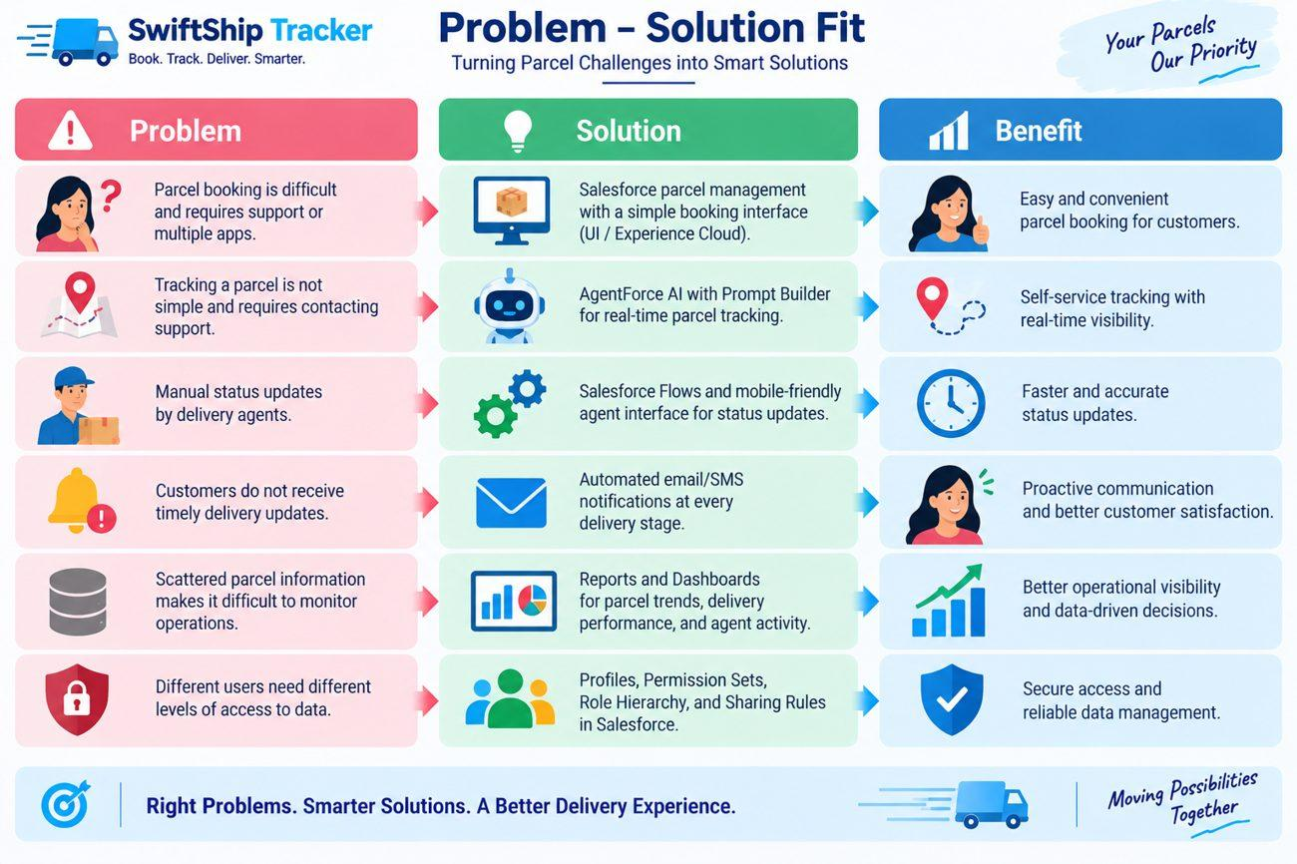
Figure 2.1: Problem-to-solution mapping used for the proposed design

CHAPTER 2 – SYSTEM STUDY

2.4 Objectives and Scope
The objectives translate the problem study into measurable project intentions. The first objective is to place parcel information in a common system. The second is to make tracking easier for customers. The third is to reduce repetitive work for operational staff. The fourth is to provide a basis for monitoring delivery activity. The fifth is to protect data through Salesforce access controls.
- Centralise shipment records and the relationships between parcel, delivery, sender and receiver information.
- Provide a simple method for retrieving parcel status and key delivery details.
- Use Salesforce automation to reduce repetitive operational actions and notification work.
- Support administrative reporting and dashboards as the project grows.
- Apply role-based and field-level access so that users receive only the permissions required for their work.
The scope covers the complete conceptual parcel lifecycle from booking to delivery confirmation. It includes the data model, Salesforce configuration, Flow-based retrieval, Prompt Builder template, AgentForce agent, security configuration and testing performed in the Developer Edition environment.
The implementation boundary is important. Batch Apex, approval processes, Experience Cloud customer access, dashboards and external logistics integrations are represented in the wider design and planning, but the documented prototype concentrates on the objects, prompt, Flow, permission set and AgentForce agent that were actually configured and verified.

CHAPTER 2 – SYSTEM STUDY

2.5 Feasibility Study
A feasibility study was used to check whether the project could be completed with the available academic resources. Because Salesforce is cloud hosted, the project did not require a dedicated application server or database server. The practical development requirement was a browser, internet access, an email account and a Salesforce Developer Edition org.
Feasibility area | Observation | Assessment
Technical | Custom objects, Flow Builder, Prompt Builder, AgentForce and security controls are available within Salesforce. | Suitable for prototype development
Economic | Developer Edition provides a free environment for learning and configuration. Production licensing would need separate evaluation. | Suitable for academic work
Operational | Users can work through familiar Salesforce interfaces; customers can interact through a conversational tracking path. | Practical with limited training
Schedule | Work was divided into six planned sprints of six days, with twenty story points allocated per sprint. | Manageable as an academic plan

Technical feasibility is also supported by the declarative nature of the platform. Many of the project components can be configured through Setup rather than being built from scratch. This shortened the time required to establish the data model and automation foundation.
Economic feasibility should not be interpreted as a statement about commercial deployment cost. The prototype environment is suitable for learning and demonstration, whereas a real parcel company would need to evaluate Salesforce edition, AgentForce usage, integration, security and operational requirements separately.

CHAPTER 3 – IDEATION PHASE

3.1 Customer Problem Statements
The ideation stage was intentionally user-centred. Before choosing a platform feature, the project team described the difficulty faced by each major user group. This helped prevent the design from becoming a collection of unrelated Salesforce capabilities.
ID | User | Need | Barrier | Effect
PS-1 | Customer/Sender | Book a parcel easily | Multiple channels or support dependence | Frustration
PS-2 | Customer/Sender | Track a shipment | Tracking information is difficult to reach | Confusion
PS-3 | Delivery Agent | Update parcel status | Updates rely on manual handling | Concern
PS-4 | Customer | Receive delivery updates | Communication may not occur at each stage | Uncertainty
PS-5 | Administrator | Monitor operations | Shipment and performance data are fragmented | Concern

The statements show that the same underlying problem affects different roles in different ways. Customers experience information gaps, agents experience manual work, and administrators experience a lack of consolidated visibility. The solution therefore needs both a customer-facing retrieval path and an operational data foundation.
Figure 3.1: Customer problem statements used during ideation

CHAPTER 3 – IDEATION PHASE

3.2 Empathy Map
The Customer/Sender persona was selected for an empathy-map exercise because this user interacts with the system from booking through delivery. The map focused on what the person thinks, hears, sees, says and does, together with the pain points and expected gains.
Dimension | Observation
Think and feel | Wants a dependable booking and tracking experience and becomes concerned when status information is unavailable.
Hear | Receives booking confirmations, delivery updates and information about delivery timing.
See | Needs parcel details, status, estimated delivery date and clear shipment communication.
Say and do | Books parcels, checks tracking information, asks for updates and shares tracking details with the receiver.
Pain | Delays, unclear status, repeated support contact and uncertainty about delivery time.
Gain | Convenient booking, visibility, timely updates and greater confidence in the delivery process.

The empathy map influenced the final design in a direct way. The pain of repeated support contact led to self-service tracking. The need for understandable status information led to a fixed response structure in the Prompt Builder template. The need for confidence during transit led to the inclusion of status, weight and estimated delivery date in the conversational response.
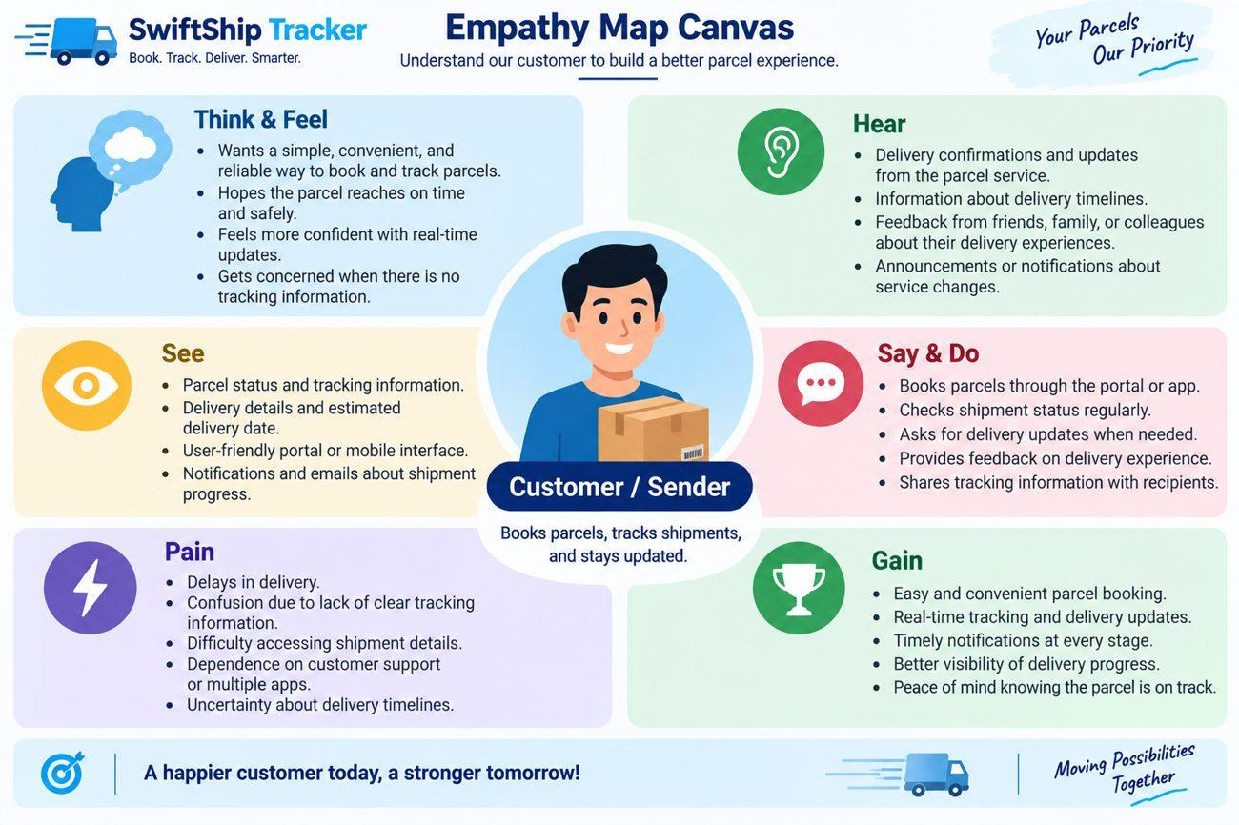
Figure 3.2: Empathy map for the Customer/Sender persona

CHAPTER 3 – IDEATION PHASE

3.3 Brainstorming and Prioritisation
Four alternatives were considered during brainstorming: manual registers, spreadsheet tracking, a standalone parcel portal and a Salesforce CRM solution enhanced with AgentForce. The purpose of the exercise was not to compare every logistics platform available in the market, but to decide which type of solution best addressed the project problem within the academic context.
Idea | Strength | Concern
Manual registers | Simple and inexpensive | Slow search, manual updates and no self-service
Spreadsheet tracking | Easy to filter and share | Weak relational structure and access control
Standalone portal | Dedicated customer interface | More development and infrastructure responsibility
Salesforce + AgentForce | Central data, automation, security and conversational access | Requires Salesforce configuration knowledge

Three qualities received particular attention during prioritisation: automation, scalability and visibility. Automation matters because parcel status and communication contain repetitive steps. Scalability matters because the same data model should remain useful as shipment volume and user count increase. Visibility matters because the customer needs current information while administrators need an operational summary.
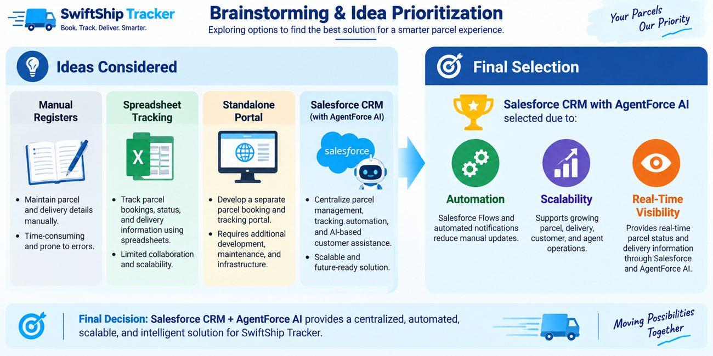
Figure 3.3: Brainstorming and prioritisation of solution ideas

CHAPTER 3 – IDEATION PHASE

3.4 Selection of the Salesforce-Based Concept
The selected concept combines conventional CRM-style record management with conversational retrieval. The important design decision was to keep the AI agent connected to governed Salesforce records rather than treating the chatbot as a separate source of information. This makes the parcel record the source of truth for the information returned to the user.
The selection also fits the project’s educational objective. A single Salesforce environment makes it possible to demonstrate data modelling, customisation, automation, access control, reporting and AI integration in one project. Each component has a clear place in the workflow rather than being added only for demonstration value.
Design decision | Reason for inclusion
Custom objects | Parcel logistics entities are not standard CRM entities and require a project-specific model.
Lookup relationships | Keep shipment entities connected without forcing a tightly coupled structure.
Flow | Provide a controlled retrieval path between the agent input and Parcel record.
Prompt Builder | Define a consistent customer-facing summary of parcel information.
AgentForce | Provide conversational access to the retrieval action.
Permission set | Give the agent user the minimum practical object and field access required for the prototype.

The result is a solution concept that can be implemented incrementally. The data model can be verified before the AI layer is introduced, and the AI layer can be tested independently before full conversational verification. This incremental approach later shaped the Agile plan.

CHAPTER 4 – REQUIREMENT ANALYSIS

4.1 Customer Journey
The customer journey describes the service from the first parcel enquiry to the operational reporting that follows the delivery. It also highlights where information is most important to the user.
Stage | System activity | User expectation
1. Enquiry | Customer checks service and delivery information | Understand available options
2. Booking | Sender and receiver details are captured | Complete booking without confusion
3. Record creation | Parcel record is stored in Salesforce | Know the shipment is registered
4. Dispatch | Shipment leaves the origin point | See that movement has started
5. In transit | Delivery location and status are updated | Track progress
6. Out for delivery | Status changes before final handover | Know delivery is imminent
7. Delivered | Delivery is confirmed | Receive completion information
8. Notification | Email or integrated message communicates progress | Stay informed
9. Reporting | Operational data becomes available for analysis | Enable management review

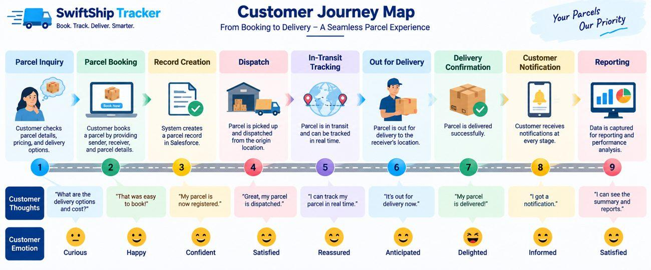
Figure 4.1: Customer journey from parcel booking to delivery

CHAPTER 4 – REQUIREMENT ANALYSIS

4.2 Functional Requirements
Functional requirements describe the behaviours expected from the solution. The requirements were mapped directly to Salesforce objects, fields, automation and interfaces so that each requirement had a concrete implementation location.
ID | Functional requirement | Salesforce support
FR-01 | Create a parcel booking record | Parcel__c with auto-numbered Parcel ID
FR-02 | Maintain shipment status | Status__c picklist
FR-03 | Store parcel weight | Weight__c number field
FR-04 | Maintain expected delivery date | Estimated_Delivery_Date__c
FR-05 | Store sender information | Sender__c and lookup
FR-06 | Store receiver information | Receiver__c and lookup
FR-07 | Maintain delivery location | Delivery__c and geolocation
FR-08 | Allow authorised staff to update records | Profiles and permission set
FR-09 | Send customer notifications | Flows, email alerts and templates
FR-10 | Answer parcel enquiries conversationally | AgentForce + Prompt Builder + Flow
FR-11 | Support management insight | Reports and dashboards
FR-12 | Provide customer self-service | Experience Cloud design

The implementation evidence is strongest for FR-01, FR-02, FR-03, FR-04, FR-05, FR-06, FR-07 and FR-10 in the Developer Edition prototype. Notifications, dashboards and Experience Cloud form part of the wider solution design and are treated accordingly in the later discussion.

CHAPTER 4 – REQUIREMENT ANALYSIS

4.3 Non-Functional Requirements
Non-functional requirements define the quality expected from the system rather than a single business action. The project considered usability, security, reliability, performance, availability, scalability, integrity and maintainability.
Quality | Requirement | Design response
Usability | Users should understand the interface and response quickly | Lightning pages and conversational interaction
Security | Access should depend on role and responsibility | Profiles, permission sets, sharing and field-level security
Reliability | Returned parcel information should reflect stored records | Single Salesforce data source and controlled Flow
Performance | Parcel retrieval should avoid unnecessary processing | Flow performs a focused record lookup
Availability | Users should access the service through the cloud | Salesforce browser-based platform
Scalability | The model should support additional shipment records | Platform-managed storage and configurable objects
Data integrity | Relationships and fields should remain consistent | Lookup relationships and controlled field types
Maintainability | Configuration should be changeable without rebuilding the whole system | Declarative Flows and Prompt Builder assets

The project does not claim a production service-level agreement or a measured enterprise performance benchmark. Performance observations in the testing chapter are limited to the Developer Edition conversation preview used during implementation.

CHAPTER 4 – REQUIREMENT ANALYSIS

4.4 Hardware and Software Requirements
Because the application runs on Salesforce, the project does not require a local server, dedicated database machine or special networking hardware. Hardware requirements apply to the devices used to reach the cloud platform.
Hardware component | Guideline
Processor | Modern dual-core processor or better
Memory | 4 GB RAM or above for comfortable browser use
Storage | Sufficient free space for browser cache and project files
Display | Laptop/desktop monitor; mobile access may be used for customer-facing views
Network | Stable broadband or mobile data connection

The software environment is similarly lightweight. A current web browser is the main client. The development environment is a Salesforce Developer Edition org, while an email account is needed for registration and verification. Google Sheets or Docs can be used for early requirement planning and mapping.
Software | Purpose
Web browser | Salesforce Setup, Flow Builder, Prompt Builder and Agent Builder
Salesforce Developer Edition | Configuration, development and testing environment
Email account | Developer org registration and verification
Google Sheets / Docs | Initial planning and documentation

CHAPTER 4 – REQUIREMENT ANALYSIS

4.5 Technology Stack
The technology stack is organised by responsibility rather than by programming language alone. Salesforce provides the platform and data layer, while declarative automation handles much of the business logic. Apex and Batch Apex are part of the planned technology set for cases where declarative automation is insufficient.
Layer | Technology / feature | Purpose
Platform | Salesforce Developer Edition | Cloud environment
UI | Lightning App, Record Pages, Experience Cloud | User interaction
Data | Custom and standard Salesforce objects | Business records
Automation | Record-triggered, auto-launched and scheduled Flows | Process automation
Server-side logic | Apex and Batch Apex | Planned programmable processing
AI | AgentForce and Prompt Builder | Conversational parcel assistance
Notifications | Email alerts and templates | Customer communication
Security | Profiles, permission sets, roles, sharing, field-level security | Controlled access
Analytics | Reports and dashboards | Operational insight

The important technical choice is the use of an auto-launched Flow between the AI agent and the Parcel record. This creates a controlled interface: the agent supplies an identifier, the Flow retrieves the matching record, the prompt formats the relevant fields, and the response is returned to the conversation.

CHAPTER 4 – REQUIREMENT ANALYSIS

4.6 User Roles and Key Needs
Role | Main responsibility | Information need
Customer / Sender | Book parcels, track shipments and receive updates | Own shipment status and delivery details
Delivery Agent | Handle assigned parcels and update delivery status | Parcel, delivery and contact information
Customer Support | Resolve delivery issues and respond to enquiries | Cases plus relevant parcel details
Administrator | Configure Salesforce, manage access and monitor operations | Full operational and configuration view
System Integrator / Developer | Implement automation and integrations | Technical configuration and system behaviour

Role separation influenced the security model. A customer does not require the same access as a delivery agent, and an agent does not require unrestricted administrative privileges. The AgentForce service user also requires explicit access because an AI agent acts through a Salesforce user context. This requirement became a practical configuration issue during implementation and was solved with the Swift Ship permission set.
The user needs also indicate that the system should minimise the amount of information a customer must provide. The core conversational interaction is intentionally simple: the customer provides a parcel ID, the agent uses the configured retrieval path, and the response contains a small set of useful shipment fields.

CHAPTER 5 – SALESFORCE OVERVIEW

5.1 Salesforce Platform
Salesforce is a cloud-based customer platform that combines data management, business applications, automation, security and reporting. Users access the environment through a browser, while the platform manages the underlying infrastructure. This cloud model fits a parcel application because shipment data, user access and workflow configuration can be maintained in one environment.
For this project, Salesforce is also a configurable development platform. Administrators can create custom objects and fields, define relationships, design interfaces and build Flows. Apex is available when server-side programming is required. The parcel domain is not represented by standard Salesforce objects alone, so the project adds a custom data model on top of the platform.
The CRM nature of Salesforce is useful because parcel operations involve people and interactions as well as shipment records. Standard objects such as Account, Contact, Case, Task, EmailMessage and User are part of the broader design. The four custom objects hold the project-specific logistics data.
Platform capability | Relevance to Swift Ship Tracker
Custom data model | Represents parcel logistics entities
Automation | Moves repetitive process steps into Flow
Security | Controls who can read or change records
AI | Connects customer questions with stored parcel data
Reporting | Provides operational summaries
Cloud access | Avoids local application infrastructure

CHAPTER 5 – SALESFORCE OVERVIEW

5.2 Platform Suitability and Developer Edition
Salesforce suits the project because the parcel lifecycle naturally maps to records, relationships and controlled status values. A shipment can be represented as a Parcel record, its movement as a Delivery record, and the two parties involved as Sender and Receiver records. Automation can respond to changes while access rules determine which users can view or edit the data.
The prototype was built in a Salesforce Developer Edition org. This environment is intended for learning and application development and provides the platform features needed to configure the academic prototype. The organisation was created through Salesforce registration, followed by email verification, password creation and access to the Setup home page.
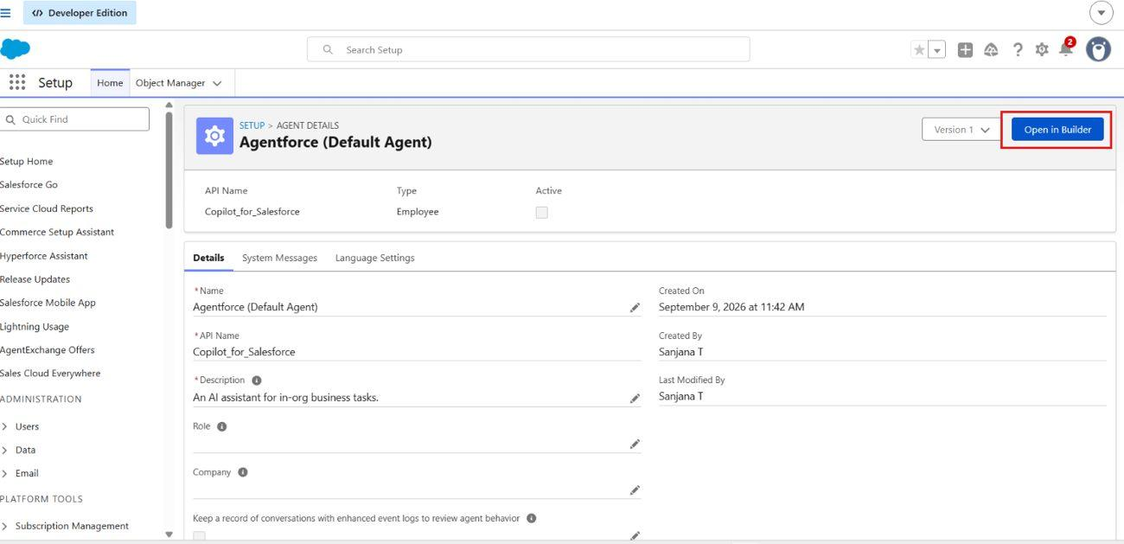
Figure 5.1: Salesforce Setup environment used as the starting point for configuration
The Developer Edition boundary also explains why production deployment was not attempted. A production implementation would require a separate deployment strategy, typically including controlled environments, testing and release management. Those activities are discussed as future deployment work rather than presented as completed project steps.

CHAPTER 5 – SALESFORCE OVERVIEW

5.3 Salesforce Features Used
Feature | Role in the project
Custom objects | Parcel__c, Delivery__c, Sender__c and Receiver__c store core logistics data
Fields and relationships | Represent identifiers, status, weight, dates, locations and links
Custom tabs | Provide direct navigation to project objects
Flows | Automate retrieval and support planned parcel operations
Apex / Batch Apex | Part of the planned programmable automation layer
Email alerts | Support booking and delivery communication design
Prompt Builder | Formats a Parcel record for conversational output
AgentForce | Hosts the SwiftShip Tracker agent and Parcel Details Inquiry subagent
Lightning pages | Provide internal record and application interfaces
Experience Cloud | Planned customer-facing access channel
Security controls | Protect objects, fields and records
Reports and dashboards | Provide operational insight in the broader solution design

The distinction between “used” and “planned” is important in this report. The core prototype implementation verified the custom objects, Prompt Builder template, Parcel Details Flow, permission set and AgentForce retrieval conversation. Several surrounding features are documented because they form part of the intended system design, but they are not claimed as fully deployed in the prototype.

CHAPTER 5 – SALESFORCE OVERVIEW

5.4 Prompt Builder and the Parcel Summary
Prompt Builder is used to define how Salesforce data should be expressed to a generative AI model. Instead of asking the agent to invent shipment information, the project supplies the relevant Parcel record and identifies the fields that belong in the response.
Property | Configured value
Template label | Retrieve Parcel Details
API name | Retrieve_Parcel_Details
Template type | Record Summary
Object | Parcel__c
Model | OpenAI GPT 4 Omni Mini (standard model type in the project)
Main fields | Name, Parcel_ID__c, Status__c, Weight__c, Estimated_Delivery_Date__c

The template instructs the model to work with the Parcel record whose Parcel ID corresponds to the user input. The response is shaped as a “Parcel Tracking Update” containing the parcel name, ID, status, weight and estimated delivery date. The fixed structure is useful because customers receive consistent information instead of a different response format on every enquiry.
Prompt Builder therefore acts as a presentation layer over governed data. The retrieval responsibility remains in the Flow, while the prompt is responsible for turning the retrieved record into a readable response. This separation keeps the architecture understandable and makes each part easier to test.
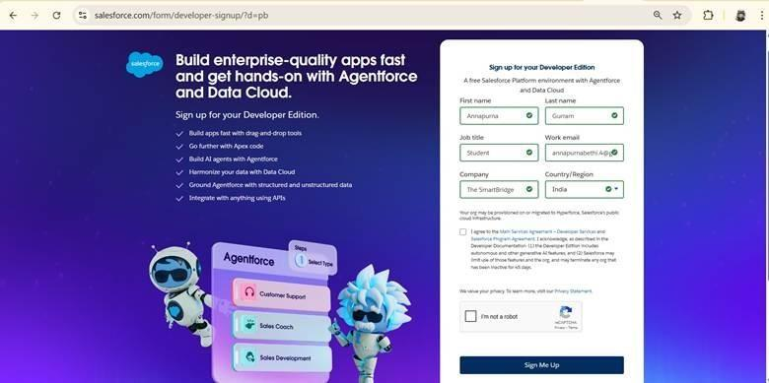
Figure 5.2: Prompt Builder / AgentForce environment used for conversational configuration

CHAPTER 5 – SALESFORCE OVERVIEW

5.5 Salesforce Flow
Flow is Salesforce’s visual automation mechanism. It provides elements such as Get Records, Assignment, Decision and Action that can be connected to build a process without writing a complete custom program. The project uses an auto-launched Flow because the parcel retrieval process is initiated by the AgentForce action rather than by a record trigger.
The Parcel Details Flow receives a text input variable named ids and exposes a text output variable named output. The Get Records element searches Parcel__c for a matching Parcel_ID__c. Once the record is found, an Action invokes the Retrieve Parcel Details prompt template. The resulting prompt response is assigned to the output variable and returned to the caller.
Flow element | Role
Start | Begins the auto-launched flow
Get Records | Finds Parcel__c where Parcel_ID__c equals the input
Action | Calls the Retrieve Parcel Details prompt template
Assignment | Copies the generated response to output
End | Returns the response to the agent

This design is intentionally small. The agent does not need to know how the Parcel object is queried, and the prompt does not need to perform record retrieval by itself. Each component has one clear responsibility.

CHAPTER 6 – SYSTEM DESIGN

6.1 Problem–Solution Fit
System design began by mapping each user problem to a specific platform capability. This avoids feature-driven development, where a technology is added without a clear connection to the business problem.
Problem | Solution component | Expected benefit
Booking information is fragmented | Central Parcel/Sender/Receiver records | One structured record set
Tracking requires support contact | AgentForce + Prompt Builder | Self-service parcel enquiry
Status updates require manual work | Flow and controlled agent interface | Faster operational updates
Communication gaps | Email-alert design | More timely notifications
Shipment information is scattered | Four related custom objects | Consistent relationships
Management visibility is limited | Reports and dashboards | Operational summaries
Different roles need different access | Profiles, roles and permission sets | Controlled information access

The mapping also reveals a dependency chain. The AI agent depends on the data model. The Flow depends on the Parcel ID and Parcel fields. The permission set is required before the agent can read the data. Therefore, the implementation order starts with the org and data model and moves toward automation, security and conversational behaviour.
Figure 6.1: Problem–solution fit diagram for Swift Ship Tracker

CHAPTER 6 – SYSTEM DESIGN

6.2 System Architecture
The architecture is layered so that user interaction, stored data, automation, AI and security can be understood separately. Customers, delivery agents, support staff and administrators form the user layer. Salesforce Lightning and Experience Cloud represent interface channels, while the conversational agent provides a specialised interaction path.
Layer | Components | Responsibility
Users | Customer, delivery agent, support staff, admin | Perform role-specific activities
Interface | Lightning, Record Pages, Experience Cloud, conversation | Capture and display information
Data | Parcel, Delivery, Sender, Receiver | Store logistics records
Automation | Flows, email alerts, Apex, Batch Apex, approvals | Process updates and notifications
AI | AgentForce, Prompt Builder, tracking agent | Interpret request and present parcel data
Security | Profiles, roles, permission sets, sharing, field security | Control access
Insight | Reports and dashboards | Summarise operations

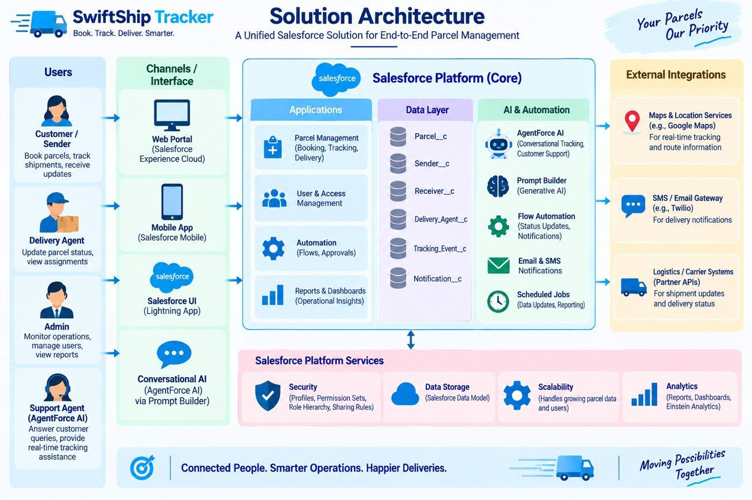
Figure 6.2: Layered solution architecture of Swift Ship Tracker
External map services, messaging gateways and logistics-carrier integrations are possible extension points in the architecture. They are not treated as implemented prototype components; instead, they show where future integrations could connect to the Salesforce solution.

CHAPTER 6 – SYSTEM DESIGN

6.3 End-to-End System Workflow
- The customer or sender initiates a parcel booking and supplies the required shipment information.
- Salesforce stores the Parcel record and associates the Sender, Receiver and Delivery records through lookups.
- The parcel is dispatched and its operational status moves through the defined lifecycle.
- Delivery staff update status and, where applicable, current location information.
- The parcel reaches the Out for Delivery stage and is later marked Delivered after handover.
- Notification mechanisms can communicate the relevant stage to the customer.
- At any point, the customer can ask the AgentForce assistant for parcel details using the parcel identifier.
- The Parcel Details Flow finds the matching record and invokes the prompt template.
- The response is returned to the conversation, while the underlying data remains in Salesforce for reporting and review.
The workflow separates operational state changes from information retrieval. A tracking question does not create a second parcel record; it reads the existing record. This is an important design property because duplicate tracking data could lead to inconsistencies between the customer interface and the operational system.

CHAPTER 6 – SYSTEM DESIGN

6.4 Data Flow
Two related data flows are important. The first is the operational parcel flow. It begins with the customer, creates or updates Salesforce records, moves through delivery status and notification, and ends in tracking and reporting. The second is the conversational flow, which begins with a user question and travels through AgentForce, the Flow and Prompt Builder before returning a formatted answer.
Stage | Operational flow | Conversational flow
Input | Customer / sender | Customer query
Core process | Parcel booking and record creation | AgentForce interprets request
Data access | Sender + Receiver + Delivery | Parcel Details Flow
Current information | Status, location, estimated date | Parcel record fields
Communication | Notifications / customer access | Prompt Builder response
Outcome | Updated shipment lifecycle | Parcel Tracking Update

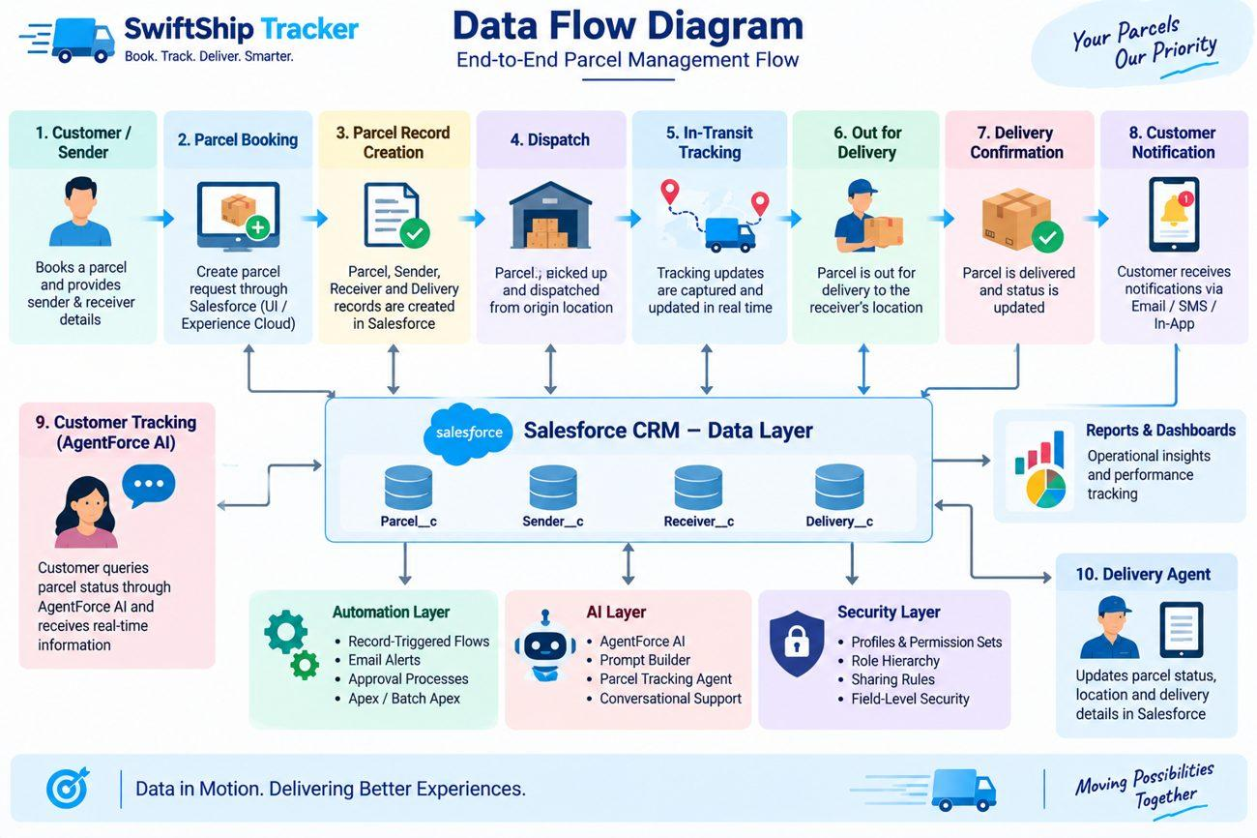
Figure 6.3: End-to-end data flow used by the project design
The conversational flow is deliberately narrow. The agent receives a parcel identifier and the Flow performs the lookup. The prompt then uses the returned record to construct the response. This reduces the risk of presenting unrelated information and makes the interaction easier to verify.

CHAPTER 6 – SYSTEM DESIGN

6.5 Data Model – Parcel and Delivery
The data model contains four custom objects. Parcel__c is the central object because it represents the shipment itself. It stores the parcel identifier, current status, weight and expected delivery date, together with a lookup to the sender.
Object | Important fields | Purpose
Parcel__c | Parcel ID, Status, Weight, Estimated Delivery, Sender | Central shipment record
Delivery__c | Current Location, Estimated Delivery, Sender, Parcel | Movement and delivery information
Sender__c | Sender Address, Sender Contact, Sender Email | Information about the person who books/sends the parcel
Receiver__c | Receiver Address, Receiver Contact, Receiver Email, Sender, Parcel | Information about the recipient

Delivery__c complements Parcel__c rather than duplicating the entire parcel record. It provides a place for movement-related information. Its Current Location field is a Geolocation field, which stores location as latitude and longitude. It also carries lookups to Parcel and Sender so that agents can reach the relevant shipment context.
Lookup relationships were chosen throughout the custom model. This keeps the objects relatively independent while still allowing users and automation to navigate between them. The approach is suitable for a prototype where records may need to be created and maintained in stages.

CHAPTER 6 – SYSTEM DESIGN

6.6 Data Model – Sender, Receiver and Relationships
From object | Related object | Field | Relationship
Parcel__c | Sender__c | Sender__c | Lookup
Delivery__c | Parcel__c | Parcel__c | Lookup
Delivery__c | Sender__c | Sender__c | Lookup
Receiver__c | Sender__c | Sender__c | Lookup
Receiver__c | Parcel__c | Parcel__c | Lookup

Sender__c stores the sender’s address coordinates, phone contact and email address. The email is relevant to the notification design because the sender should be able to receive booking and delivery information. Receiver__c follows the same pattern for the recipient and additionally connects to the sender and parcel records.
The model creates a traceable path. Starting from a Parcel record, a user can reach the sender, then inspect receiver information and the delivery record. Starting from a Receiver record, the linked parcel provides the shipment context. This is useful for both operations and support because the same business information can be reached from more than one user workflow.
Field names shown in the implementation reflect Salesforce-generated API naming. In particular, labels containing punctuation or possessive forms may produce API names that differ from the planned label wording. The implementation records the names visible in the org rather than inventing alternate names after the fact.

CHAPTER 7 – PROJECT PLANNING AND SCHEDULING

7.1 Agile Development Approach
The project followed an Agile-style planning approach. Work was organised as epics and user stories, and each story received a story-point estimate representing relative effort. Six short sprints were planned, with a nominal capacity of twenty points per sprint.
Agile was useful because Salesforce configuration can be validated in small increments. A custom object can be created and inspected before other objects are added. A Flow can be tested in debug mode soon after it is built. A Prompt Builder template can be previewed against a real record. This means each sprint can produce a tangible configuration result rather than waiting until the end of development.
Sprint | Primary focus | Planned points
1 | Developer environment | 20
2 | Data modelling and navigation | 20
3 | Automation and validation | 20
4 | Apex / operational processing | 20
5 | Reports and analytics | 20
6 | Dashboards and AI | 20

The backlog was deliberately arranged according to dependency. The environment is required before objects can be created. Objects and fields are required before meaningful automation can be written. The AI agent depends on the data model, Flow and access configuration. This dependency-aware order reduced the risk of building a user interface around data structures that might later change.

CHAPTER 7 – PROJECT PLANNING AND SCHEDULING

7.2 Product Backlog
Story | Task | Points | Priority
USN-1 | Create and configure Salesforce environment | 3 | High
USN-2 | Create Parcel, Delivery, Sender and Receiver objects and relationships | 5 | High
USN-3 | Create tabs and Lightning navigation | 5 | High
USN-4 | Validate parcel details and booking inputs | 3 | High
USN-5 | Build Flow automation for parcel processing | 3 | High
USN-6 | Develop Apex support for critical actions | 5 | High
USN-7 | Use Batch Apex for periodic operational processing | 5 | High
USN-8 | Create reports for status and delivery performance | 4 | High
USN-9 | Build dashboards and AgentForce assistance | 4 | Medium

The backlog contains both prototype work and broader planned functionality. The first implemented path concentrated on the data model and conversational retrieval because those components demonstrate the central project idea. Apex, Batch Apex, reports and dashboards were retained in the planning record to show the intended expansion path of the system.
The story-point values should be interpreted as relative effort rather than hours. They provide a consistent planning unit and help compare the size of work across sprints. The recorded plan allocated twenty points to each sprint, giving 120 planned points across the six-sprint schedule.

CHAPTER 7 – PROJECT PLANNING AND SCHEDULING

7.3 Sprint Tracker and Velocity
Sprint | Start | End | Capacity | Recorded completion
Sprint 1 | 24 Oct 2022 | 29 Oct 2022 | 20 | 20
Sprint 2 | 31 Oct 2022 | 05 Nov 2022 | 20 | —
Sprint 3 | 07 Nov 2022 | 12 Nov 2022 | 20 | —
Sprint 4 | 14 Nov 2022 | 19 Nov 2022 | 20 | —
Sprint 5 | 21 Nov 2022 | 26 Nov 2022 | 20 | —
Sprint 6 | 28 Nov 2022 | 03 Dec 2022 | 20 | —

The planning record shows Sprint 1 completed with all twenty allocated points on its planned release date. The later sprint dates are retained as the schedule recorded in the project plan; the report does not reinterpret them as evidence of completed production releases.
With 120 planned points and six equal sprint capacities, the ideal planning velocity is approximately 3.3 points per working day. In practice, velocity is meaningful only when actual completed work is recorded consistently. For an academic project, the tracker is most useful as evidence that work was broken into manageable increments and that dependencies were considered.
The same principle is visible in the implementation chapter. The project starts with environment creation and object modelling, then moves to fields, Prompt Builder and Flow, followed by security and AgentForce. Testing comes after the individual components have been configured.

CHAPTER 7 – PROJECT PLANNING AND SCHEDULING

7.4 Burndown Perspective
A burndown chart represents the amount of work remaining against time. The project plan contains 120 story points in total, distributed evenly across six sprints. If the plan were completed at a constant rate, the ideal remaining work would fall by twenty points at the end of each sprint.
Point in plan | Ideal remaining work
Start | 120
End of Sprint 1 | 100
End of Sprint 2 | 80
End of Sprint 3 | 60
End of Sprint 4 | 40
End of Sprint 5 | 20
End of Sprint 6 | 0

The burndown perspective is useful because it converts a list of tasks into a time-based view. A higher-than-ideal remaining value indicates that work is behind the planned trajectory, while a lower value indicates that work has been completed earlier. In the recorded plan, Sprint 1 completed its full allocation, so the first sprint aligns with the ideal reduction.
For this report, the burndown is treated as a planning model rather than as a claim about a measured production team velocity. The later project chapters provide more direct evidence for the components that were actually configured and tested in the Developer Edition org.

CHAPTER 8 – IMPLEMENTATION

8.1 Development Phases
Implementation was divided into five broad phases. Phase 1 established the requirements and design. Phase 2 created the Salesforce environment and the main backend configuration. Phase 3 addressed access control and the AgentForce user experience. Phase 4 focused on verification, data checks and security validation. Phase 5 covers documentation, maintenance and the boundary between prototype validation and future deployment.
Phase | Focus | Main milestones
1 | Requirements and planning | Scope, personas, data model, security and feature selection
2 | Salesforce configuration | Developer org, objects, tabs, fields, Prompt Builder, Flow
3 | UI and agent setup | Permission set, agent user access, AgentForce configuration
4 | Testing and security | Agent verification, topic/action checks, data validation
5 | Deployment and maintenance | Developer-org validation, monitoring, troubleshooting and documentation

The implementation sequence was intentionally incremental. The project first created the records that the AI would eventually retrieve. Only after the data model and prompt were available was the Flow connected to the prompt. The agent was then given the Flow as an action and tested with a real parcel record.

CHAPTER 8 – IMPLEMENTATION

8.2 Salesforce Account and Developer Org
The implementation began with the creation of a Salesforce Developer Edition org. The registration form required basic identity and organisation information. After submission, Salesforce sent a verification message to the registered email address. The verification link opened the account setup page, where the password and security question were configured.
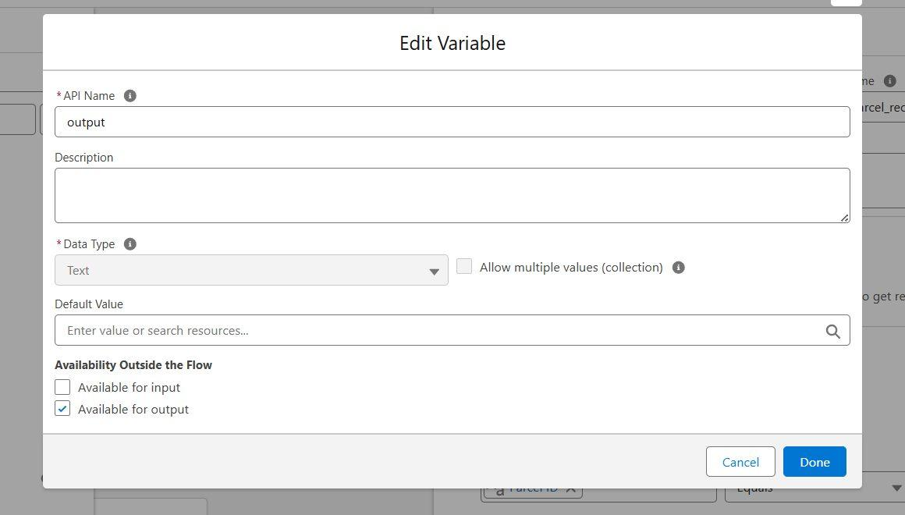
Figure 8.1: Developer Edition verification / account setup step
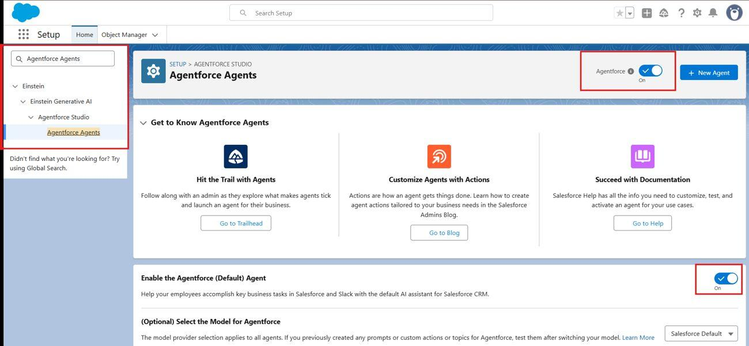
Figure 8.2: Salesforce Setup home page after organisation creation
Once the Setup home page was available, the remaining configuration could be performed through Object Manager, Setup search and the relevant Salesforce builders. The Developer Edition environment provided the working space for creating custom objects, fields, Flow and AgentForce assets.
This step is foundational because every later component is stored in the org. A configuration error at the environment level can prevent access to the builders or the AI agent. The project therefore treated account verification and Setup access as the first milestone before data modelling began.

CHAPTER 8 – IMPLEMENTATION

8.3 Creating the Custom Objects
Four custom objects were created through Object Manager. The same general procedure was followed for each object: create the custom object, specify the label and plural label, select the record-name type, enable useful object options and deploy the object.
Object | Plural label | API name | Record name
Parcel | Parcels | Parcel__c | Name (Text)
Delivery | Deliveries | Delivery__c | DeliveryName (Text)
Sender | Sender’s | Sender__c | SenderName (Text)
Receiver | Receiver’s | Receiver__c | ReceiverName (Text)

Reports, search and field-history tracking were enabled as part of the object configuration. Field history is particularly relevant to a parcel service because status and location can change during the shipment lifecycle. A record history provides useful evidence when an operational question asks when a value changed.
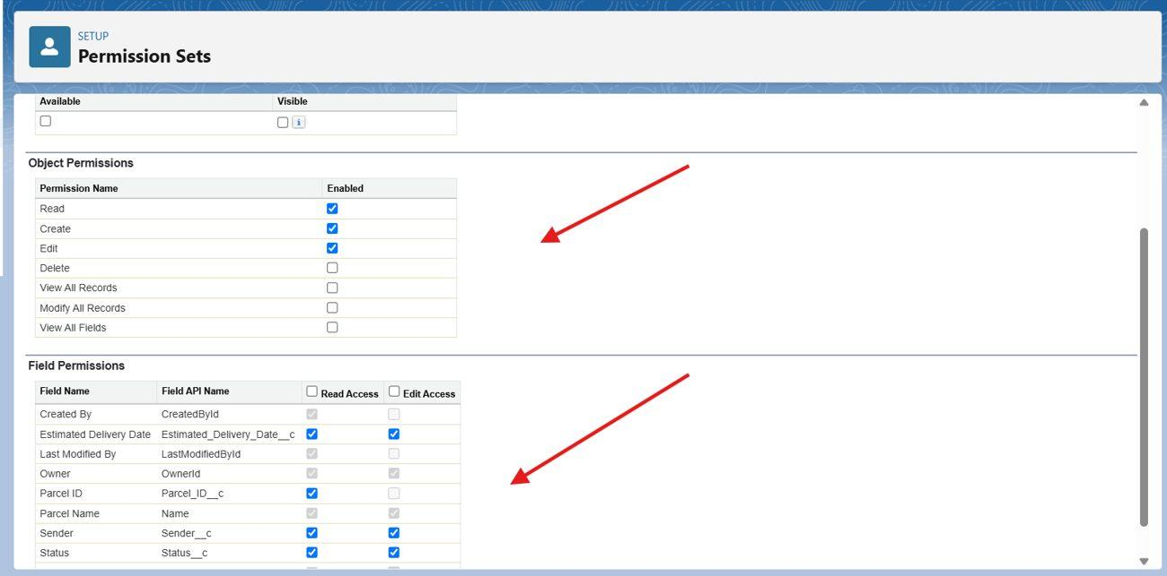
Figure 8.3: Custom object configuration in Object Manager
The four objects form the minimum relational foundation for the project. Parcel represents the shipment, Delivery represents its movement, and Sender and Receiver represent the two people associated with the transaction. The next implementation step was to expose these objects through custom tabs and then add the fields and lookup relationships.

CHAPTER 8 – IMPLEMENTATION

8.4 Creating Custom Tabs
Custom tabs provide direct navigation to custom object records. The tabs were created through Setup by searching for Tabs, opening the User Interface section and selecting New under Custom Object Tabs. The required object and tab style were selected for each of the four project objects.
Tab | Object | Purpose
Parcel | Parcel__c | Open and manage shipment records
Delivery | Delivery__c | View delivery movement information
Sender | Sender__c | Maintain sender details
Receiver | Receiver__c | Maintain receiver details

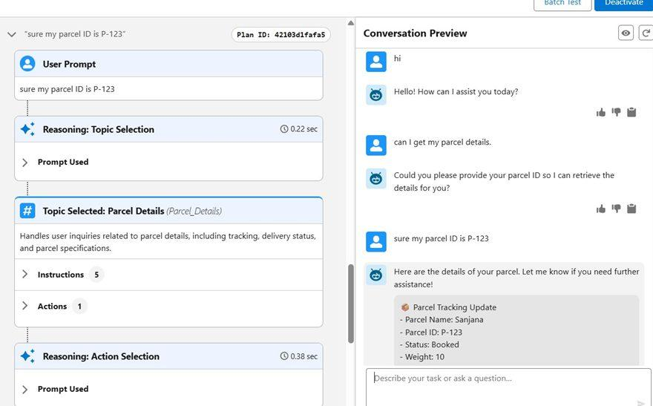
Figure 8.4: Custom tabs and navigation configuration
The tab configuration supports the operational user journey. An agent does not have to search for the underlying object through Setup; the relevant records can be reached from the application navigation. The same object-level structure also supports later Lightning Record Page customisation.
The implementation intentionally kept the navigation simple. The project’s main challenge is not to create a large number of screens but to establish a reliable relationship between the data, automation and conversational interface. Tabs are therefore treated as the navigation layer over the data model.

CHAPTER 8 – IMPLEMENTATION

8.5 Parcel Fields and Relationships
The Parcel object was configured with the fields required for tracking. The Parcel ID uses Salesforce Auto Number with the format P-{000} and starts from 1. This produces identifiers such as P-001 without requiring a user to type the tracking number manually.
Field label | API name | Type | Purpose
Parcel ID | Parcel_ID__c | Auto Number | Unique shipment identifier
Status | Status__c | Picklist | Booked, In Transit, Out for Delivery, Delivered
Weight | Weight__c | Number | Parcel weight
Estimated Delivery | Estimated_Delivery_Date__c | Date | Expected delivery date
Sender | Sender__c | Lookup | Links shipment to sender

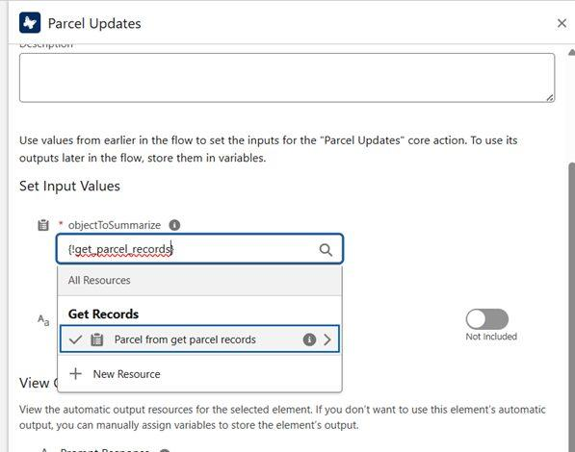
Figure 8.5: Parcel ID auto-number configuration
The Status field is important to the customer journey because it represents the major delivery stages. The Auto Number field is equally important to the AI path: the customer supplies the identifier, and the Flow uses the same value to find the Parcel record.
The Sender lookup prevents sender information from being stored repeatedly on every parcel record. Instead, the Parcel points to a Sender record that can be reused for additional shipments. This creates a simple relational model while keeping the parcel record focused on shipment-specific information.

CHAPTER 8 – IMPLEMENTATION

8.6 Delivery, Sender and Receiver Fields
Object | Field | Type | Purpose
Delivery__c | Current Location | Geolocation | Stores latitude and longitude
Delivery__c | Estimated Delivery | Date | Expected delivery date
Delivery__c | Sender | Lookup | Connects delivery to sender
Delivery__c | Parcel | Lookup | Connects delivery to parcel
Sender__c | Sender Address | Geolocation | Stores sender location
Sender__c | Sender Contact | Phone | Sender contact number
Sender__c | Sender Email | Email | Notification address
Receiver__c | Receiver Address | Geolocation | Stores receiver location
Receiver__c | Receiver Contact | Phone | Receiver contact number
Receiver__c | Receiver Email | Email | Notification address
Receiver__c | Sender | Lookup | Connects receiver and sender
Receiver__c | Parcel | Lookup | Connects receiver and parcel

The geolocation fields were configured because location is relevant to a delivery service. The contact and email fields provide the communication details needed by the notification design. The lookup fields keep the records connected to the central parcel context.
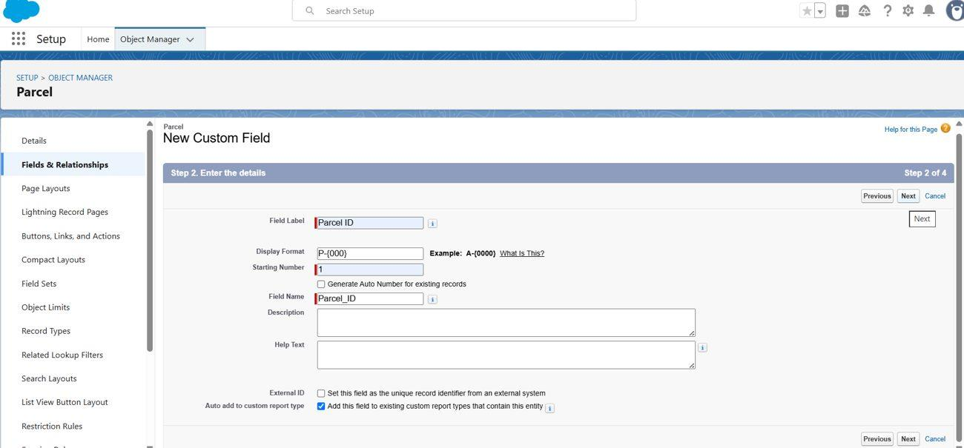
Figure 8.6: Field and relationship configuration within a Salesforce object
Salesforce generates API names from labels, so the exact API spelling of fields containing punctuation or possessive wording can differ from a planning document. The implementation records the API names visible in the org and uses those names when configuring permissions and automation.

CHAPTER 8 – IMPLEMENTATION

8.7 Prompt Builder Configuration
The Prompt Builder template was created after the Parcel object and its fields were available. A Record Summary template was selected and associated with Parcel__c. The template was named “Retrieve Parcel Details” and was configured to use the fields needed for a concise tracking response.
Prompt property | Value
Label | Retrieve Parcel Details
API name | Retrieve_Parcel_Details
Type | Record Summary
Object | Parcel__c
Input fields | Name, Parcel_ID__c, Status__c, Weight__c, Estimated_Delivery_Date__c
Response heading | Parcel Tracking Update

The prompt instructs the model to use the Parcel record whose Parcel_ID__c corresponds to the user’s input and to return the selected fields in a fixed format. This approach makes the response predictable and reduces unnecessary conversational variation.
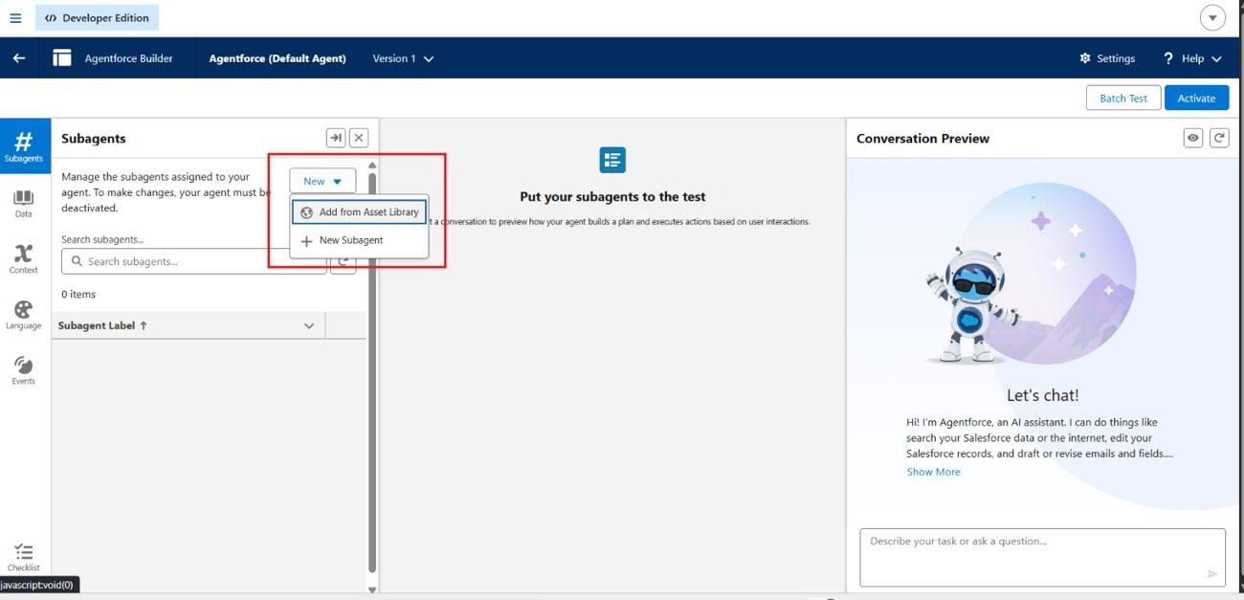
Figure 8.7: Prompt template editor and resource configuration
The template was saved and activated so that it could be called from the Flow. Prompt Builder therefore became the formatting layer in the retrieval chain, while record lookup remained the responsibility of Salesforce Flow.

CHAPTER 8 – IMPLEMENTATION

8.8 Prompt Preview and Response Verification
Prompt Builder provides a preview mode in which the template can be evaluated against an actual record. A Parcel record was selected as the test input and the generated response was reviewed. The project test record used parcel ID P-123, status Booked, weight 10 and an estimated delivery date of 09/29/2025.
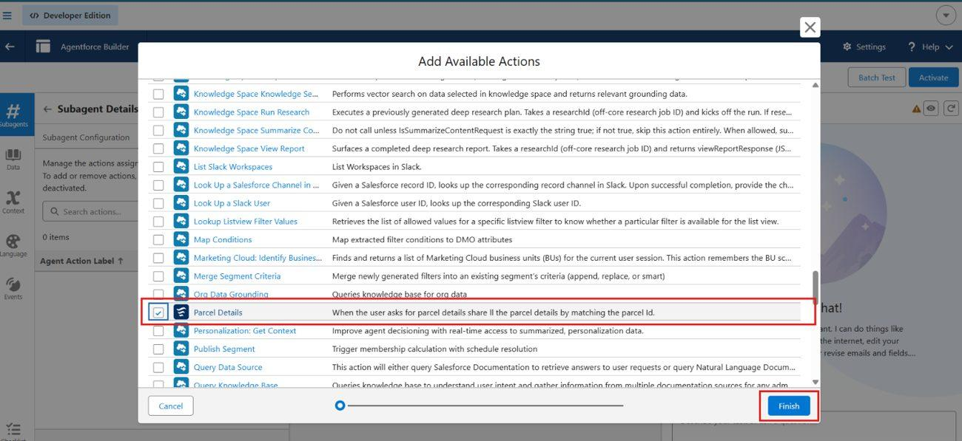
Figure 8.8: Prompt preview showing resolved input and generated response
The preview confirmed that the selected merge fields were resolved from the record and that the response contained the intended parcel information. This test was important before connecting the prompt to the Flow because it isolated the AI formatting step from the rest of the system.
The output structure used in the project is headed “Parcel Tracking Update” and contains the parcel name, Parcel ID, status, weight and estimated delivery date. A fixed output format is useful in a tracking service because customers generally need a short operational answer rather than a long general explanation.
This component-level test also established a baseline for later conversation testing. If the agent subsequently returned incorrect text, the team could compare it against the prompt preview and determine whether the problem was in the prompt, the Flow or the agent configuration.

CHAPTER 8 – IMPLEMENTATION

8.9 Creating the Parcel Details Flow
The Parcel Details Flow was created from Setup using New Flow and the Autolaunched Flow (No Trigger) type. The choice of an auto-launched flow reflects the integration point: the Flow is started by an AgentForce action rather than by a record being created or changed.
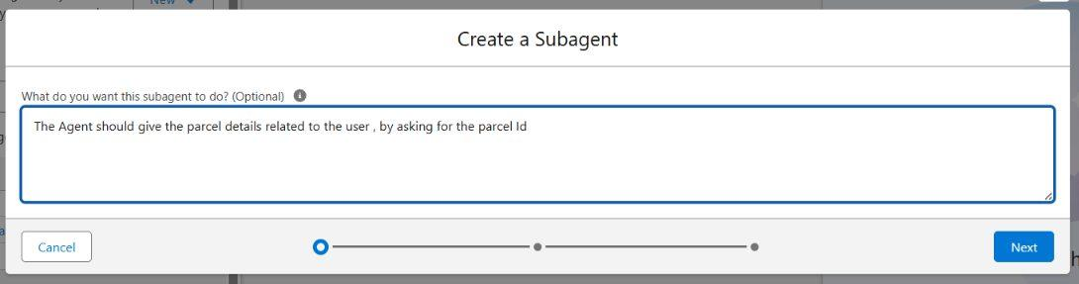
Figure 8.9: Selecting the auto-launched Flow type
Resource | Type | Availability | Purpose
ids | Text variable | Input | Receives parcel identifier from the agent
output | Text variable | Output | Returns formatted response to the agent

The two variables form a simple contract between AgentForce and Flow. The agent supplies ids, the Flow performs the lookup and processing, and the result is returned through output. Keeping the interface small makes the action easier to configure and test.
This design also separates the conversational layer from Salesforce data access. The agent does not directly implement a query against the Parcel object. Instead, it invokes a defined Flow whose steps can be inspected, tested and permission-controlled inside Salesforce.

CHAPTER 8 – IMPLEMENTATION

8.10 Flow Elements and Logic
Order | Element | Configuration
1 | Start | Auto-launched; no trigger
2 | Get Records | Parcel__c where Parcel_ID__c equals ids
3 | Action | Invoke Retrieve Parcel Details using the retrieved Parcel record
4 | Assignment | Set output equal to prompt response
5 | End | Return output to caller

The Get Records element is the key lookup step. It searches the Parcel object using the same identifier that the customer supplied. The next Action element sends the retrieved record to the Prompt Builder template. The Assignment then transfers the generated text into the output variable.
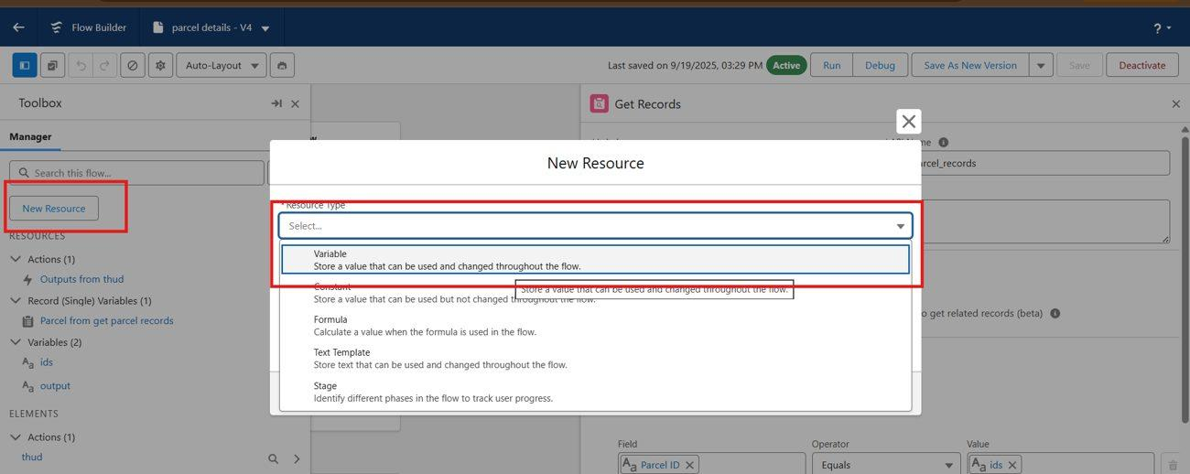
Figure 8.10: Flow configuration showing the parcel retrieval path
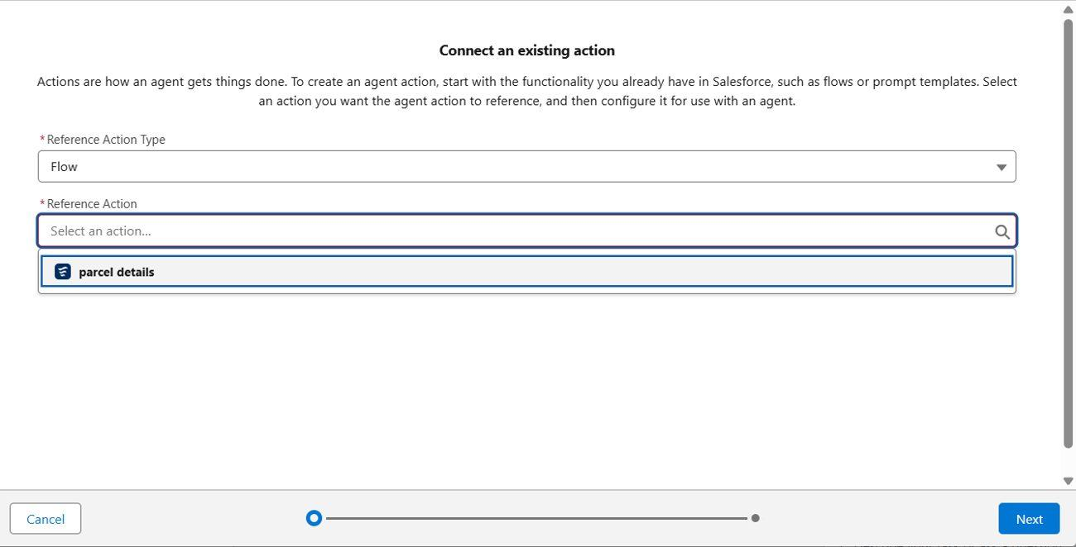
Figure 8.11: Flow action and output assignment configuration
After the elements were connected in sequence, the Flow was saved as “Parcel Details” and activated. The completed path is intentionally linear, which makes it easy to reason about during testing: input, lookup, prompt action, output assignment and return.

CHAPTER 8 – IMPLEMENTATION

8.11 Flow Access and Implementation Checkpoint
Creating a Flow is not sufficient when an AgentForce user needs to execute it. Flow access must be enabled for the relevant user profiles. The project therefore opened the Flow’s Edit Access settings and moved the required profiles into the enabled list.
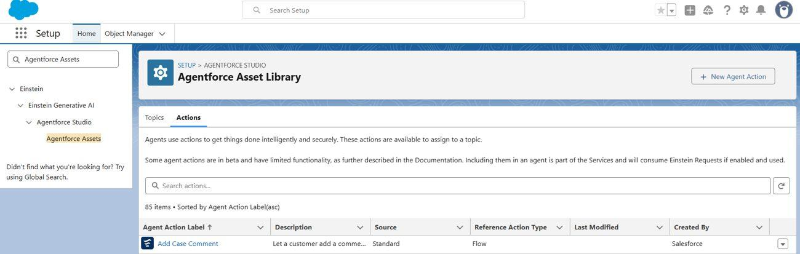
Figure 8.12: Flow access configuration for enabled profiles
At the end of this milestone, the project had the core retrieval chain in place: Parcel__c contained the shipment data, the Prompt Builder template defined the response, Parcel Details retrieved the matching record and the required profile access allowed the Flow to execute.
Checkpoint | Expected state
Parcel object | Created and searchable
Parcel ID | Auto-number field available
Prompt template | Saved and active
Parcel Details Flow | Saved and active
Input variable | ids available to caller
Output variable | output available to caller
Flow access | Required profile enabled

This checkpoint was used as the foundation for the next phase. Security was configured before the agent was finalised because the agent operates under a Salesforce user context and therefore cannot bypass object or field permissions simply because it is an AI component.

CHAPTER 9 – SECURITY, AGENT SETUP AND USER INTERFACE

9.1 Security Model
Security was treated as part of the system design rather than as a final cosmetic step. Parcel records contain contact information and delivery details, so access must depend on user responsibility. The design combines a role hierarchy, profiles, permission sets, record-level sharing and field-level security.
Profile / role | Expected access
Administrator | Full configuration and record access
Delivery Agent | Read and edit access to parcel-related records needed for delivery work
Customer | Read-only access to own parcel information through the customer channel
Support Staff | Cases and relevant parcel information for issue resolution
Manager hierarchy | Visibility over records belonging to users below the manager where applicable

The role hierarchy provides a supervisory structure, while profiles establish baseline permissions. Permission sets add specific privileges without changing the base profile. Sharing rules can control which records become visible, and field-level security can restrict sensitive fields such as email, contact and location values.
The AgentForce user required a dedicated permission set because the conversational action is still subject to Salesforce security. This practical requirement became one of the main security configuration steps in the implementation.

CHAPTER 9 – SECURITY, AGENT SETUP AND USER INTERFACE

9.2 Swift Ship Permission Set
A permission set named “Swift Ship” was created for the AgentForce service user. The Einstein Agent licence was selected, and Object Settings were used to configure access to the four custom objects.
Object | Read | Create | Edit | Delete
Parcel__c | Yes | Yes | Yes | No
Delivery__c | Yes | Yes | Yes | No
Sender__c | Yes | Yes | Yes | No
Receiver__c | Yes | Yes | Yes | No

Object | Important fields made available
Parcel__c | Estimated Delivery Date, Parcel ID, Sender, Status
Delivery__c | Current Location, Estimated Delivery Date, Parcel
Sender__c | Sender Address, Sender Contact, Sender Email
Receiver__c | Parcel, Receiver Address, Receiver Contact, Receiver

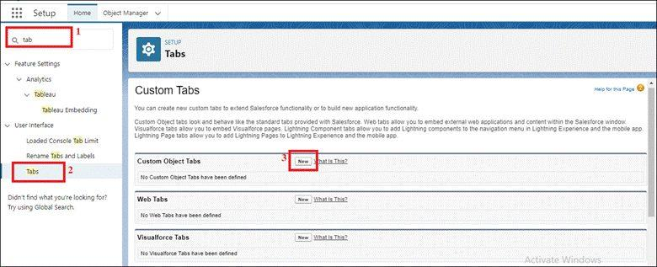
Figure 9.1: Swift Ship permission set / object access configuration
Delete access was not enabled in the project permission set. This is consistent with the principle of granting only the capabilities required for the retrieval and operational path. The exact production permissions would need to be reviewed against the final business process before deployment.

CHAPTER 9 – SECURITY, AGENT SETUP AND USER INTERFACE

9.3 Agent User Assignment and Org Preparation
The permission set only becomes effective after assignment to a user. The Einstein Service Agent user was opened from Setup, and the Swift Ship permission set was moved into the enabled assignments. The user record then showed the existing Agentforce Service Agent Secure Base permission set together with Swift Ship.
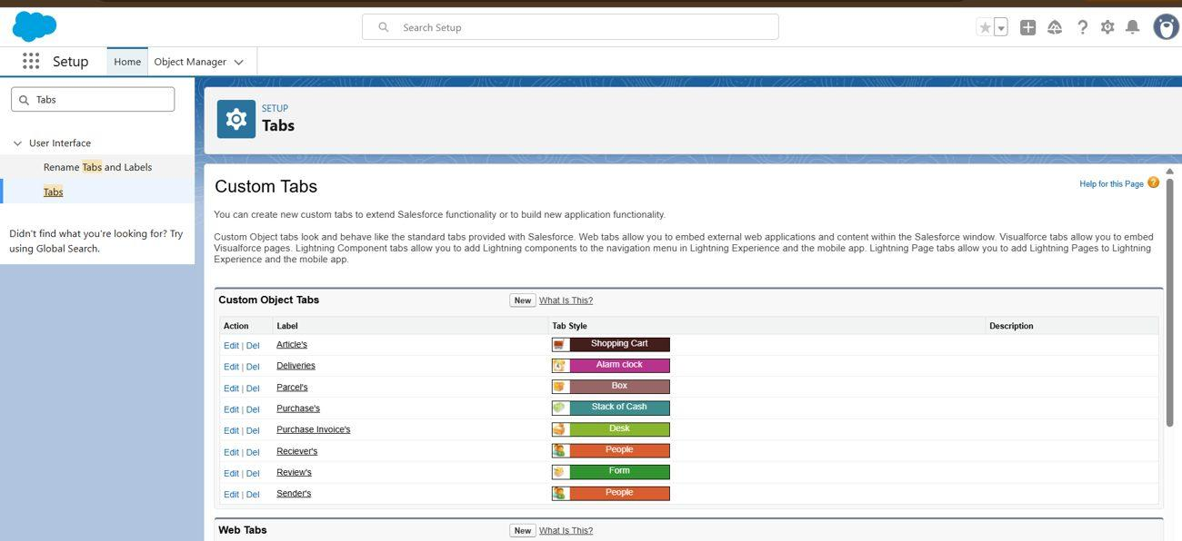
Figure 9.2: Assigning the Swift Ship permission set to the agent user
The org was then prepared for AgentForce. The project enabled the default agent from Salesforce Go, turned on Einstein, enabled Global Languages for Prompt Builder and enabled deployment of prompt templates. AgentForce and the default agent were then enabled from the Agentforce Agents page.
Configuration area | Setting | State
Salesforce Go | Default agent | On
Einstein Setup | Turn on Einstein | On
Einstein Setup | Global Languages | On
Einstein Setup | Deploy Prompt Templates | On
Agentforce Agents | Agentforce | On
Agentforce Agents | Default Agent | On

These settings provide the platform-level foundation needed before the custom agent can be configured. The project treated this as a separate step so that organisation-level configuration problems could be distinguished from problems inside the agent itself.

CHAPTER 9 – SECURITY, AGENT SETUP AND USER INTERFACE

9.4 Creating the Parcel Details Inquiry Subagent
The AgentForce agent was built from the default agent in Agentforce Builder. A dedicated subagent named “Parcel Details Inquiry” was created for requests involving parcel information. Its purpose was described in terms of asking the user for a parcel ID and retrieving the corresponding parcel details.
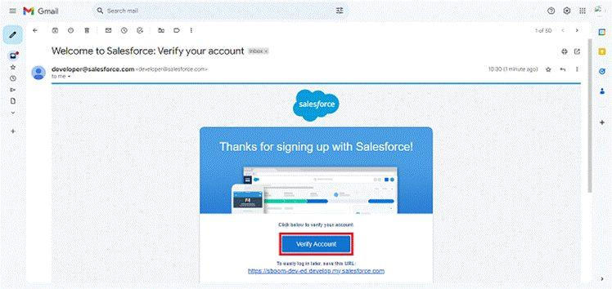
Figure 9.3: AgentForce Builder environment used to create the parcel subagent
The subagent contains classification information and scope. The classification helps the agent decide when a request belongs to this topic, while the scope keeps the subagent focused on the parcel retrieval task. This is important because a conversational agent may eventually contain several subagents for different business functions.
The project did not treat the subagent as the source of shipment data. Instead, it was given an action backed by the Parcel Details Flow. This creates a clear boundary: the subagent recognises the request, the action calls the Flow, the Flow retrieves the record and Prompt Builder prepares the response.

CHAPTER 9 – SECURITY, AGENT SETUP AND USER INTERFACE

9.5 Creating and Assigning the Agent Action
Agent actions are the mechanism through which the conversational agent performs a defined operation. From the AgentForce Asset Library, the project created a new action and selected Flow as the reference action type. The previously activated Parcel Details Flow was then selected.
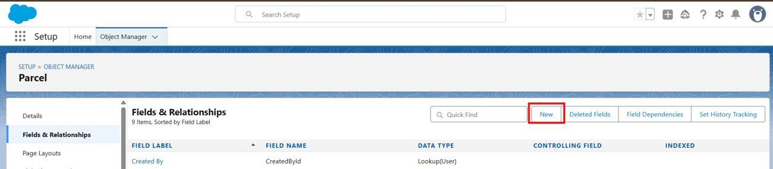
Figure 9.4: Selecting the Parcel Details Flow as the AgentForce action source
After the action was saved, it was assigned to the Parcel Details Inquiry subagent through the subagent’s action list. The result is a single retrieval action associated with the parcel topic.
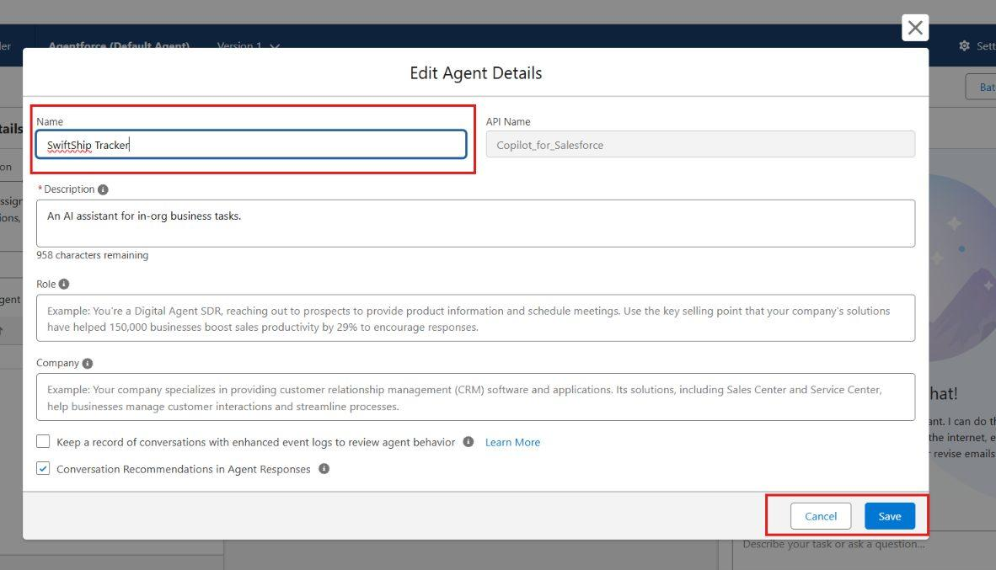
Figure 9.5: Adding the Parcel Details action to the parcel subagent
The agent was renamed “SwiftShip Tracker” through the agent settings. When activation was attempted, the builder displayed configuration warnings relating to overlapping subagents, conflicting instructions and Data Cloud not being enabled. The project recorded these warnings and used the available Ignore & Activate option because the warnings did not prevent the configured parcel-retrieval function from operating in the Developer Edition environment.

CHAPTER 9 – SECURITY, AGENT SETUP AND USER INTERFACE

9.6 User Interface and Activation
The system has three interface paths. Internal users work through the Salesforce Lightning application and record pages. Customers are intended to use Experience Cloud or other customer-facing access for self-service. The conversational path provides direct interaction with the AgentForce service.
Interface | Primary users | Purpose
Lightning application | Administrators, agents, support | Create, view and update internal records
Lightning Record Pages | Internal users | Display parcel and related details
Experience Cloud | Customers | Self-service access to permitted shipment information
AgentForce conversation | Customers / staff | Natural-language parcel enquiry

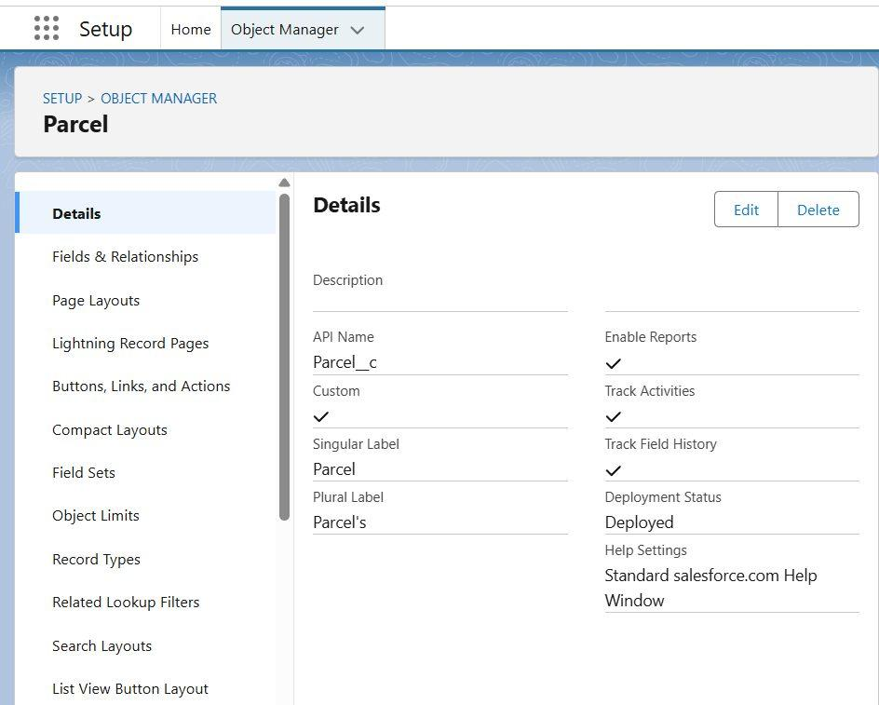
Figure 9.6: Salesforce record interface showing related parcel information
The interface design keeps the conversational response focused. A user can greet the agent, ask for parcel details, receive a request for the parcel ID and then receive the Parcel Tracking Update. The agent does not need to expose the underlying Flow steps to the customer.
At this point the core system is ready for end-to-end testing. The next chapter checks not only the conversation, but also the underlying prompt, Flow state, action assignment, record values and security permissions.

CHAPTER 10 – TESTING

10.1 Testing Methodology
Testing was carried out inside the Salesforce Developer Edition org. The main questions were whether the agent recognises the parcel topic, whether it invokes the assigned Flow, whether the Flow retrieves the correct Parcel record and whether the user context has enough access to complete the operation.
Testing was performed from the bottom of the dependency chain upward. First, the Prompt Builder template was previewed against a real record. Next, the Flow configuration and active state were checked. The agent, subagent and action association were then verified. Finally, a complete conversation was performed using a parcel identifier.
Testing level | What was checked | Evidence
Component | Prompt resolves correct fields | Prompt Builder preview
Component | Flow retrieves parcel and returns output | Flow Builder / active Flow
Configuration | Agent, subagent and action are present | AgentForce Builder
Functional | Conversation returns parcel information | Agent preview
Data | Returned values match Salesforce records | Parcel and related records
Security | Agent user can access required objects and Flow | Permission set and Flow access

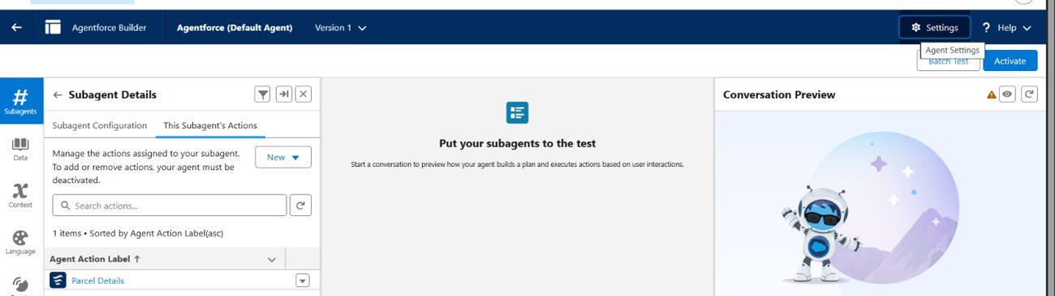
Figure 10.1: Agent list / active configuration used during verification

CHAPTER 10 – TESTING

10.2 Test Cases and Results
ID | Test | Expected | Observed
TC-01 | Preview P-123 in Prompt Builder | Formatted tracking update | Pass: name, ID, status, weight and date displayed
TC-02 | Send “hi” to agent | Polite greeting and assistance | Pass
TC-03 | Ask for parcel details without ID | Agent requests parcel ID | Pass
TC-04 | Provide P-123 | Parcel topic selected and action runs | Pass
TC-05 | Retrieve P-123 | Correct parcel information returned | Pass
TC-06 | Check Flow state | Parcel Details is active | Pass
TC-07 | Check agent state | SwiftShip Tracker is active | Pass
TC-08 | Check subagent action | Parcel Details is assigned | Pass
TC-09 | Open related records | Saved values are visible | Pass

The central functional test is the sequence represented by TC-04 and TC-05. The user first supplies the parcel ID, after which the agent selects the Parcel Details topic and invokes the action. The returned message begins with a parcel-tracking response and includes the requested fields from the record.
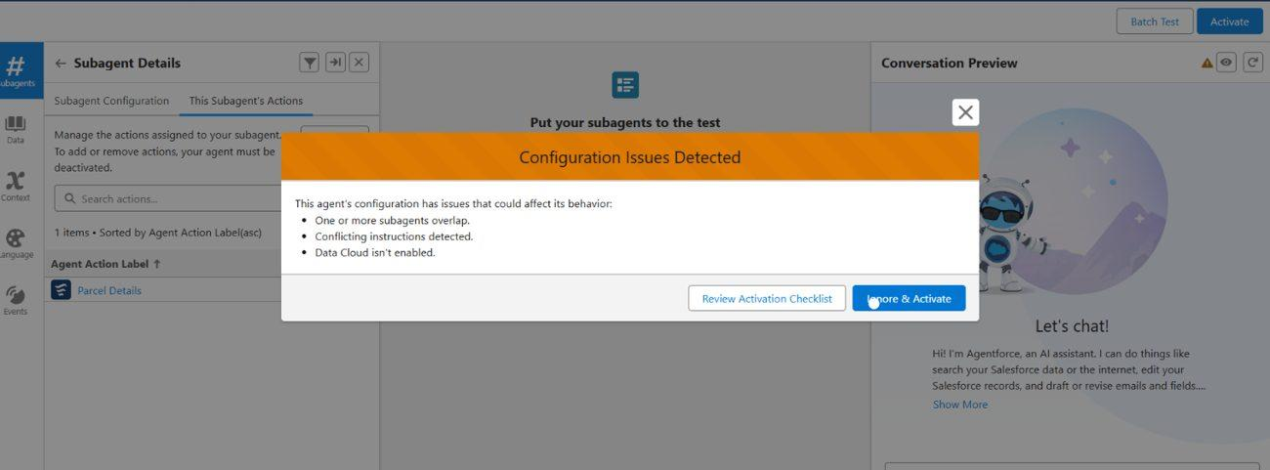
Figure 10.2: Conversation/testing configuration used during the agent verification
The project notes that the conversation preview recorded short reasoning times for topic and action selection. These timings are observations from the Developer Edition preview and should not be treated as a production performance benchmark.

CHAPTER 10 – TESTING

10.3 Data Validation and Deployment Scope
After the conversation test, the underlying Salesforce data was inspected. The Parcels tab was opened and the test parcel was located. The stored status and related values were checked against the information returned by the agent. The Receiver record displayed in the Lightning interface was also reviewed to confirm that its email, contact, address and related parcel information were present.
Scenario for further verification | Expected behaviour
Valid parcel ID | Return the matching parcel details
Unknown parcel ID | Explain that no matching record was found
Status update request | Behaviour depends on actions assigned; retrieval-only action is currently configured
Unauthorised profile | Flow execution should be blocked if access is not enabled
Customer isolation | Customer should not access another customer’s parcel
Status change | Configured notification mechanism should communicate the update when implemented

Deployment was intentionally limited to the Developer Edition org. The project did not perform production-style user acceptance testing, sandbox deployment or CI/CD release management. A Developer Edition org is a standalone learning environment, so enterprise deployment activities are outside the documented prototype scope.
This boundary is important for interpreting the test results. The tests establish that the configured retrieval chain works in the development environment. They do not establish production-scale availability, security certification or performance under a large number of concurrent users.

CHAPTER 10 – TESTING

10.4 Maintenance, Monitoring and Troubleshooting
An AI-enabled parcel system requires monitoring after deployment because several components can change independently. Parcel data can become outdated, Flow permissions can change, prompt instructions can be refined and agent topics can overlap. Maintenance therefore covers both conventional Salesforce configuration and conversational behaviour.
Issue | Likely cause | Corrective action
Wrong topic selected | Subagent descriptions overlap | Refine classification and scope
Flow fails | Missing access, invalid ID or changed field | Check permissions and debug Flow
Weak response | Prompt lacks specificity or data is missing | Refine prompt and verify fields
Agent cannot read a field | Field permission is missing | Update permission set
Old shipment information | Operational record was not updated | Review update process and automation

Monitoring should focus on the full chain rather than the agent alone. If the agent gives an unexpected answer, the investigation should begin with the Parcel record, then the Flow lookup, then the prompt inputs and finally the subagent/action configuration. This layered troubleshooting approach reduces the chance of changing the wrong component.
Regular maintenance would also include reviewing Flow versions, checking permission assignments, updating prompt instructions and monitoring records for stale delivery status. These activities become more important if the prototype is extended into a production service.

CHAPTER 11 – RESULTS AND DISCUSSION

11.1 Results Against Objectives
The implementation achieved the principal prototype objective: a customer can supply a parcel identifier to the SwiftShip Tracker conversational agent and receive parcel information retrieved from Salesforce. The successful interaction depends on several connected components rather than on the agent alone.
Objective | Observed result
Centralise parcel information | Achieved through Parcel, Delivery, Sender and Receiver objects
Simplify tracking | Achieved through the SwiftShip Tracker conversation
Enable conversational access | Achieved through AgentForce, Prompt Builder and Parcel Details Flow
Provide secure agent access | Achieved through Swift Ship permission set and Flow access configuration
Automate notifications | Designed through Flow/email features; broader automation remains part of the extended solution
Provide analytics | Included in the planned design; production-style dashboard validation remains future work

The strongest evidence is the tested retrieval path. Prompt Builder returned the expected information for the test parcel, the Flow was active, the subagent contained the action, and the agent returned the parcel details after receiving the ID. The results therefore demonstrate functional integration between data, automation and conversational AI within the development environment.

CHAPTER 11 – RESULTS AND DISCUSSION

11.2 Discussion, Advantages, Limitations and Challenges
One important observation from the project is that the quality of the AI response depends heavily on the quality of the underlying data model. Once the Parcel record, Flow and prompt were correctly configured, the conversational layer became comparatively straightforward. The project therefore reinforces the principle that AI features should be connected to structured business data rather than treated as a replacement for data design.
Another observation is that security affects AI integration directly. The AgentForce user is still a Salesforce user and requires the appropriate object and field permissions. The Swift Ship permission set and Flow access configuration were necessary parts of the working solution.
Area | Project observation
Advantages | Centralised records, conversational tracking, configurable automation, role-based security and future extensibility
Limitations | Depends on accurate data, correct configuration and suitable Salesforce access
Prototype boundary | Developer Edition only; no sandbox/UAT or production deployment
Challenge | Agent user lacked required record access initially
Solution | Created and assigned Swift Ship permission set
Challenge | Agent activation displayed configuration warnings
Solution | Reviewed warnings and activated in the Developer Edition where retrieval remained functional

The project also faces the normal maintenance burden of a configurable cloud system. Business-process changes can require Flow updates, prompt changes, permission reviews and additional testing. External carrier integrations and real-time location feeds would add another layer of complexity beyond the current prototype.

CHAPTER 12 – CONCLUSION AND FUTURE SCOPE

12.1 Conclusion and 12.2 Future Scope
Swift Ship Tracker demonstrates how Salesforce can be configured as a parcel-management platform rather than being limited to conventional customer records. The project combines a custom logistics data model with Flow automation, security controls and a conversational AgentForce experience. The central retrieval path links a user-provided parcel ID to a Salesforce record and presents the stored shipment information in a consistent format.
The project also provided practical experience across several layers of cloud application development: requirement analysis, object and relationship design, configuration, prompt engineering, automation, access control, testing and documentation. The Developer Edition implementation establishes a functional prototype while clearly identifying the work required for a production deployment.
Future area | Possible enhancement
AI | Add more parcel-related intents and actions, with improved conversational guidance
Tracking | Connect richer real-time delivery location information
Customer service | Expand Experience Cloud self-service capabilities
Analytics | Introduce deeper delivery-performance dashboards
Integration | Connect external logistics or carrier systems
Deployment | Adopt sandbox, staging and CI/CD release practices
Automation | Extend Flow/Apex automation to additional parcel operations

In conclusion, the project provides a practical foundation for a secure and customer-oriented parcel management application. Its strongest prototype feature is the controlled integration of Salesforce data, Flow and AgentForce. Future work can build on that foundation without changing the central principle that operational records remain the governed source of shipment information.

REFERENCES
[1] Salesforce Developers, “Developer Edition Sign Up”, Salesforce Developer resources.
[2] Salesforce Help, documentation on Custom Objects and Custom Fields.
[3] Salesforce Help, documentation on Flow Builder and Flow Types.
[4] Salesforce Help, documentation on Prompt Builder and Prompt Templates.
[5] Salesforce Help, documentation on Agentforce Agent Builder, subagents and actions.
[6] Salesforce Help, documentation on Permission Sets and User Access.
[7] Salesforce Trailhead, modules covering Salesforce Platform Basics, Data Modelling and Flow Basics.
[8] Salesforce Developers, Apex Developer Guide, including Apex classes and Batch Apex.
[9] Schwaber, K. and Sutherland, J., The Scrum Guide, for Agile planning terminology used in the project.
The project-specific technical facts in this report are derived from the associated Swift Ship Tracker project documentation and its Salesforce implementation evidence. Platform references are listed to identify the conceptual sources used for understanding Salesforce terminology and procedures.

APPENDIX

A. Components, Custom Fields and Glossary
Category | Components
Custom objects | Parcel, Delivery, Sender, Receiver
Standard objects | Account, Contact, Case, Task, EmailMessage, User
Automation | Flows, approval processes, email alerts
Apex | Apex classes, Batch Apex
AI | AgentForce, Prompt Builder
User interface | Lightning app, Record Pages, Experience Cloud
Security | Profiles, roles, permission sets, sharing rules, field-level security
Analytics | Reports and dashboards
Testing | Prompt, Flow, AgentForce, data and permission validation

Object | Custom fields
Parcel__c | Parcel ID, Status, Weight, Estimated Delivery, Sender
Delivery__c | Current Location, Estimated Delivery, Sender, Parcel
Sender__c | Sender Address, Sender Contact, Sender Email
Receiver__c | Receiver Address, Receiver Contact, Receiver Email, Sender, Parcel

Term | Meaning
AgentForce | Salesforce framework for building AI agents
Apex | Salesforce programming language for server-side logic
Batch Apex | Apex processing designed for batches of records
CRM | Customer Relationship Management
Custom object | Business-specific Salesforce data object
Experience Cloud | Salesforce capability for external-facing sites and portals
Flow | Salesforce visual automation tool
Lookup relationship | Relationship connecting one Salesforce record to another
Permission set | Additional permissions assigned to a user
Profile | Baseline set of Salesforce permissions
Prompt Builder | Tool for creating and managing AI prompt templates
Subagent / Topic | Focused group of agent instructions and actions
Sprint | Short, fixed period used for Agile work
Story point | Relative unit used to estimate effort

— END OF PROJECT DOCUMENTATION —

